
3298 Route 343 (East Main Street) PO Box 15 Amenia, New York 12501-0015
TEL: 845.373.8555 FAX: 845.373.9850 eMail: havensre@verizon.net
www.havensre.com

Licensed Real Estate Broker

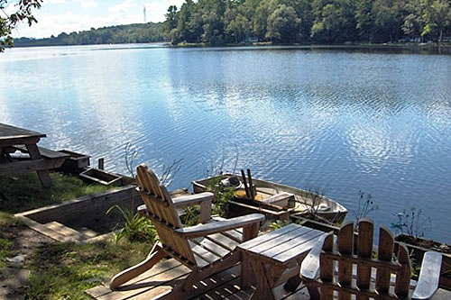 | At Water's Edge  464 Sharon Road  Millerton, NY  The ultimate retreat at the edge of Indian Lake. This cabin is not winterized. Can only be used from April 1 thru November 30. Just recently redecorated and a new roof. The cedar shake siding is only on one side. Privately owned lake does not have public access. Land is leased at $500.00 per year. Privately owned lake does not have public access.  Price: $85,000 (SOLD)  Taxes: $876.00(2004)
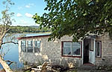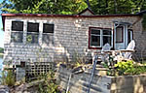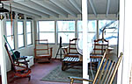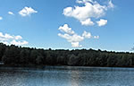

Style: | Bungalow | Bedrooms: | 3
Stories: | 1 | Bathrooms: | 1
Square Feet: | 844 | Living Room: | 23 x 17
Lot Size: | 100 x 100 approx. | Dining Room:
Year Built: | 1940 | Kitchen: | 12 x 9
Floors: | Wood | Family Room:
Basement: | On piers, crawl | Bedroom #1: | 11 x 11
Garage: | None | Bedroom #2: | 10 x 9
Heat: | None | Bedroom #2: | 14 x 7
Additional:

Deck & Dock
Mid-Hudson MLS: #226167
CCND MLS: #57922

The real estate data for sale on this website is subject to errors, omissions, changes, and withdrawal without notice. Information deemed to be reliable but not guaranteed.

