
Licensed Real Estate Broker
3300 Route 343 (East Main Street) PO Box 15 Amenia, New York 12501-0015
TEL: 845.373.8555 FAX: 845.373.9850 eMail: havensre@verizon.net
www.havensre.com

Quality Home
Stateline Road, Millerton, New York
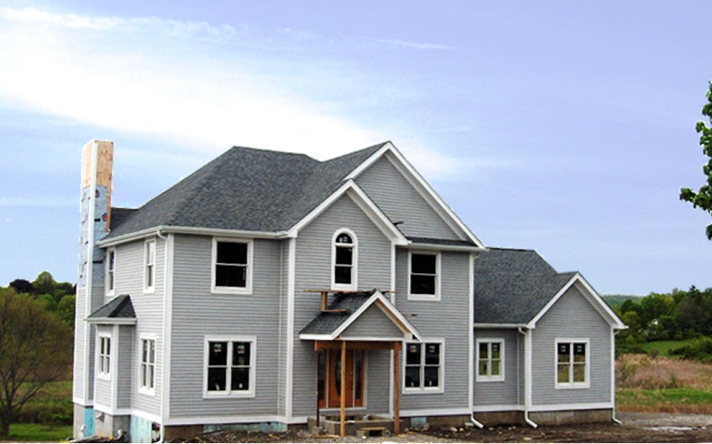
$599,000 (SOLD)

Style: Colonial Living Room: 14’ x 11’

Stories: 3 Dining Room: 14’ x 11’

Square Feet: 3,629 Kitchen: 17’ x 12’

Lot Size: 3.07 acres Breakfast Room: 11’ x 11’
Year Built: 2006 Master Bedroom: 15’ x 15’
Taxes: TBD Master Bath: 11’ x 11’
Exterior: Clapboard Bedroom: #2: 12’ x 12’
Fireplaces: 1 Bedroom: #3: 13’ x 11’
Garage: 3 car attached Bedroom: #4 13’ x 11’
Electric: 200 amp Media Room: 22’ x 11’
Basement: 715 Sq Ft finished Foyer: 14’ x 6’

A dream home with Quality! Quality! Quality! Real Construction, Real Wood! real plywood, custom moldings, solid wood doors, fine bathrooms, ceramic and hardwood floors, high end fixtures and appliances with a state of the art gourmet kitchen. The spacious rooms and flowing floor plan will satisfy the demands of the hectic lifestyles of today. State Parks, Rail Trail, Golf, Skiing, charming Villages and Metro North are all nearby.

The real estate data for sale on this website is subject to errors, omissions, changes, and withdrawal without notice. Information deemed to be reliable but not guaranteed.

