
Licensed Real Estate Broker
3300 Route 343 (East Main Street) PO Box 15 Amenia, New York 12501-0015
TEL: 845.373.8555 FAX: 845.373.9850 eMail: havensre@verizon.net
www.havensre.com

Quaint Village Location
37 Simmons Street, Millerton, NY
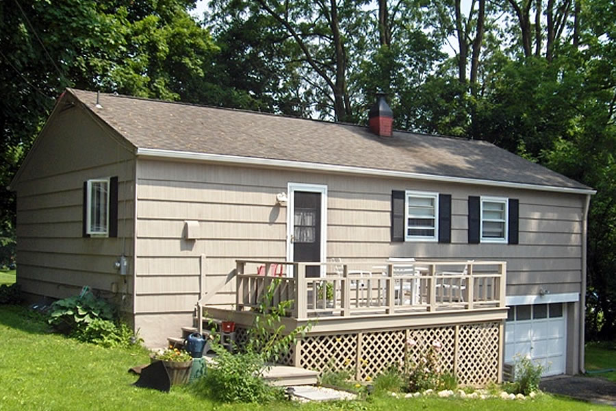
$229,000 “SOLD”

Style: Ranch Bedrooms: 3

Stories: 1 Bathroom: 1 Full

Square Feet: 996 Living Room: 19’ x 11’

Lot Size: 0.17 acres Kitchen: 13’ x 11’
Year Built: 1960 Bedroom: 14’ x 11’
Taxes: $2,890.00 (2006) Bedroom: 11’ x 10’
Exterior: Cedar Shake Bedroom: 11’ x 9’
Driveway: Blacktop
Heat: BBHW Oil

A fine village home on a fine village street. The best of small town living in this immaculate 3 bedroom ranch with gleaming hardwood floors. It’s the perfect size home to alleviate the stress of management. This is the perfect location for an effortless walk to the center of the village. Swimming, shopping, the Rail Trail and State Parks are all very convenient to this adorable home on a lovely village street.

The real estate data for sale on this website is subject to errors, omissions, changes, and withdrawal without notice. Information deemed to be reliable but not guaranteed.

