Millerton, New York

Licensed Real Estate Broker
3298 Route 343 (East Main Street) PO Box 15 Amenia, New York 12501-0015
TEL: 845.373.8555 FAX: 845.373.9850 eMail: havensre@verizon.net
www.havensre.com

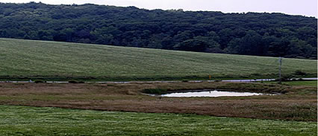

$395,000 (SOLD)
Lot Size: 14.60 Taxes: $2,357

This incredible meadow includes a spring fed pond with a Southern facing slope that features a spectacular Catskill view. The sunsets are breathtaking. Located in the Town of North East and surrounded by fine properties. Board of Health approved.

The real estate data for sale on this website is subject to errors, omissions, changes, and withdrawal without notice. Information deemed to be reliable but not guaranteed.

