
3298 Route 343 (East Main Street) PO Box 15 Amenia, New York 12501-0015
TEL: 845.373.8555 FAX: 845.373.9850 eMail: havensre@verizon.net
www.havensre.com

Licensed Real Estate Broker

Apartment Complex

327 South Amenia Rd, Amenia, New York

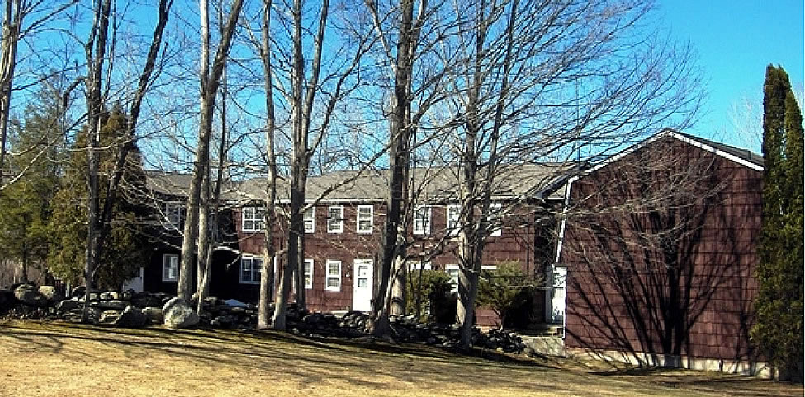
Now SOLD

Style: Multi Apartment Zoning: RM

Stories: 3 Levels Taxes: $10,506 (2007)

Square Feet: 9,6000 Apartments: 2 - 3 bedroom units

Lot Size: 1.21 acres 4 – 2 bedroom units
Exterior: Cedar Shake Baths: 1.5 baths in each unit
Roof: AS (2000) Garage: 1 car under each unit
Heat: Electric Water: Private water company
Year Built: 1972 Septic: Each unit has its own tank
CCNDMLS # 66099 MHMLS # 253181

This amazing building features 6 apartments that are in impeccable condition. All are clean and bright with hardwood floors in the living rooms and bedrooms, the bathrooms and kitchens that have been updated. With storage and a 1 car garage in the basement there may be more space in each apartment than in many homes. The 3 bedroom apartments are 1,800 sq ft, the 2 bedroom apartments are 1,500 sq ft. Located just 3.8 miles from the Wassaic Train Station, the distance from Kent, CT is 7.3 miles; Sharon, Ct 6.3 miles; Amenia, NY 6.9 miles. This building will set the standard for the overall condition of investment properties.

The real estate data for sale on this website is subject to errors, omissions, changes, and withdrawal without notice. Information deemed to be reliable but not guaranteed.

