
3298 Route 343 (East Main Street) PO Box 15 Amenia, New York 12501-0015
TEL: 845.373.8555 FAX: 845.373.9850 eMail: havensre@verizon.net
www.havensre.com

Licensed Real Estate Broker

Cascade Mountain Road, Amenia, New York
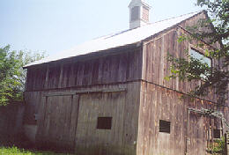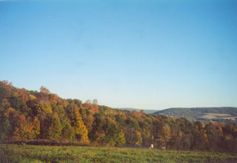
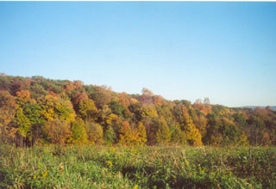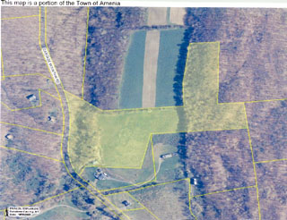

$339,000 (SOLD)

Lot Size: 20 acres
Taxes: $2,733 (2004)

Pleasant to the eye. This very private 20 acres offers a blend of meadow and woodland with superb vistas of the unspoiled countryside. Parcel varies in terrain but the meadow is fairly level and at an elevation that offers the spectacular view. A driveway has been established to the two-story barn. Parcel fronts Cascade Mountain Road and has a deeded right of way from Folan Road. Minutes from the Metro North train, Silo Ridge, State Parks and Rail Trail.

The real estate data for sale on this website is subject to errors, omissions, changes, and withdrawal without notice. Information deemed to be reliable but not guaranteed.

