Privacy in the Hills of North East
Minutes to the train in one direction and minutes to the Village of Millerton in the other!

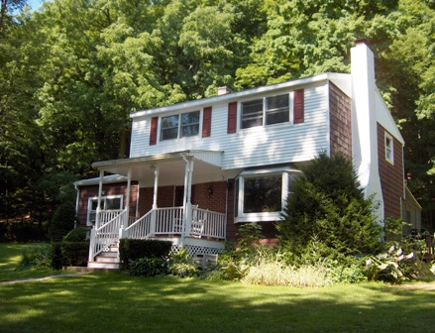
$359,000 NOW $319,000 (SOLD)

Style: Colonial Bedrooms: 4

Stories: 2 Baths: 1 Full 1 Half

Square Feet: 1,780 Living Room: 20’ x 12’

Lot Size: 7.45 acres Dining Room: 11’ x 10’
Year Built: 1972 Kitchen: 11’ x 10’
Taxes: $5,818 Family Room: 23’ x 11’
Bedroom: #1: 13’ x 12’
Exterior: Cedar/Vinyl Bedroom: #2: 11’ x 9’
Garage: None Bedroom: #3: 10’ x 9’
Heat: BBHW Oil Bedroom: #4: 11’ x 9’

Licensed Real Estate Broker
The perfect home to raise a family. Well maintained and extremely charming this is a wonderful location with a feel of home in the country. With just one owner this home participated in the successful raising of four children that now have started their own families. Now the proud grandparents want to be closer to their children’s children. This is an unbelievable opportunity! Only minutes to the Harlem Valley Rail Trail, golf, skiing, shooting range, riding and State Parks. Warm inviting living room with fireplace, an extra special kitchen w/recessed lighting, cherry cabinets, Corian countertops, the family room serves a variety of purposes and the screened porch is just perfect for summer entertaining.

The real estate data for sale on this website is subject to errors, omissions, changes, and withdrawal without notice. Information deemed to be reliable but not guaranteed.
3300 Route 343 (East Main Street) PO Box 15 Amenia, New York 12501-0015
TEL: 845.373.8555 FAX: 845.373.9850 eMail: havensre@verizon.net
www.havensre.com

