
Licensed Real Estate Broker
3298 Route 343 (East Main Street) PO Box 15 Amenia, New York 12501-0015
TEL: 845.373.8555 FAX: 845.373.9850 email: havensre@optonline.net
www.havensre.com

The Big Reward
96 Long Lake Rd, Town of Ancram
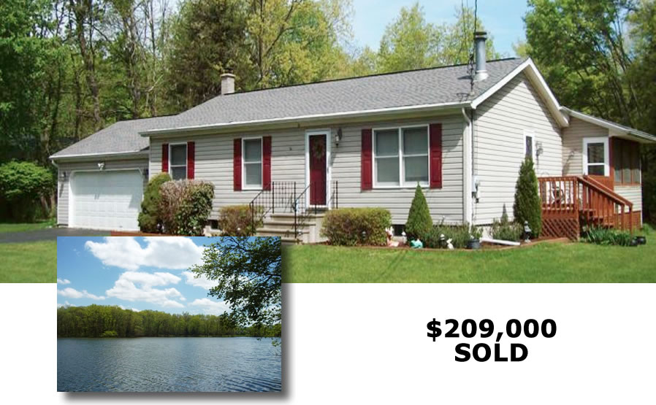

Style: Ranch Bedrooms: 3 Bathrooms: 1

Stories: 1 Living Room: 18’ x 12’ w/ FP

Square Feet: 1,494 Kitchen: 19’ x 12’

Lot Size: .8 acres Master Bedroom: 14’ x 12’
Year Built: 1989 Bedroom: 12’ x 10’
Taxes: $4,319 (2014) w/ no exemptions Bedroom: 10' x 9'
Exterior: Vinyl Screened Porch: 17' x 14'
Electric: 200 Amps, Basement: Full w/finished family room
Heat: BBHW oil Roof: Asphalt Shingle
CCND MLS: #97227 Mid-Hudson MLS: #328680
The perfect location and setting for this extraordinary 3 bedroom home and property. The incredible screened porch and finished family room put this home over the top! Impeccably maintained inside and out with an inviting and pleasing yard with plenty of room for pets and gardens. The out of doors is an extension of this well cared for home. There is extremely easy access to Route 22 and the Taconic State Parkway to travel both North and South. Deeded Lake Rights to Long Lake and just minutes to Copake Lake and the Copake Golf Coarse. Hiking, biking, swimming and a gorgeous countryside all at your door step.

The real estate data for sale on this website is subject to errors, omissions, changes, and withdrawal without notice. Information deemed to be reliable but not guaranteed.

