
Licensed Real Estate Broker
3300 Route 343 (East Main Street) PO Box 15 Amenia, New York 12501-0015
TEL: 845.373.8555 FAX: 845.373.9850 email: havensre@optonline.net
www.havensre.com

Home Sweet Home
85 Rudd Pond Road, Town of North East, New York
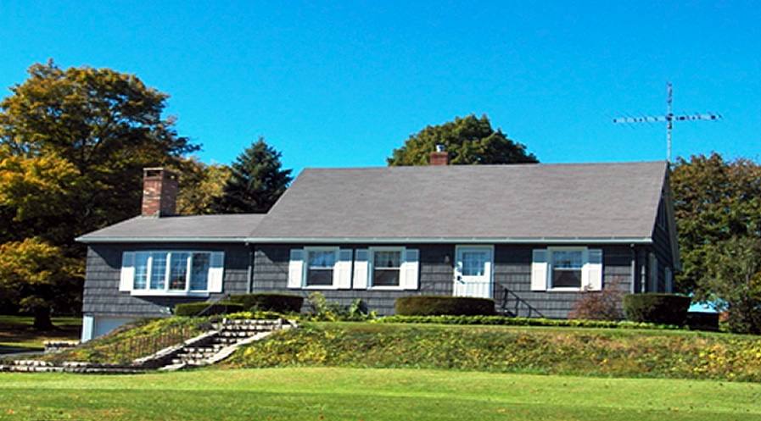
SOLD

Style: Cape Bedrooms: 3 Bathrooms: 2.5

Stories: 2 Living Room: 23’ x 17’ w/ FP

Square Feet: 1,797 Kitchen: 17’ x 10’

Lot Size: 1.05 acres Dining Room: 18’ x 11’
Year Built: 1952 Master Bedroom: 17’ x 12’
Taxes: $4,578 (2010) Bedroom: 12’ x 11’
Exterior: Shakes Bedroom: 11’ x 9’
Roof: Asphalt Shingle Sitting Room/ Office: 21’ x 17’
Electric: 200 Amps, circuit breakers Mid-Hudson MLS: #271397
Heat: BBHW oil CCND MLS: #71904

They just do not build them like this anymore. The foundation is solid concrete; the sub flooring is diagonal decking, hardwood floors that are real and in remarkable condition. The living room is an addition that added character and incredible space with an amazing fireplace and classic cherry cabinets. The second floor addition created a fabulous master bedroom and sitting room or office. A half bath serves those rooms. The property consists of two parcels; one with the house and the other is vacant. This home has been proudly maintained. The possibilities are plentiful. The Village of Millerton is a short walk and very convenient to Golf, State Parks and Metro North.

The real estate data for sale on this website is subject to errors, omissions, changes, and withdrawal without notice. Information deemed to be reliable but not guaranteed.

