
Licensed Real Estate Broker
3298 Route 343 (East Main Street) PO Box 15 Amenia, New York 12501-0015
TEL: 845.373.8555 FAX: 845.373.9850 eMail: havensre@verizon.net
www.havensre.com

Picture Perfect
81 Rudd Pond Road, Millerton, New York
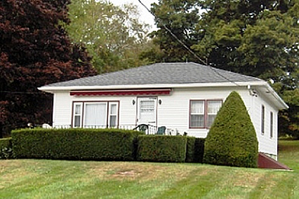
$239,000 (SOLD)

Style: Ranch Bedrooms: 2

Stories: 1 Bathrooms: 1

Square Feet: 976 Living Room: 15’ x 13’6”

Lot Size: 0.45 acres Kitchen: 13’ x 12’
Year Built: 1952 Bedroom: 13’ x 11’3”
Taxes: $2,386 (2005) Bedroom: 11’3” x 11’3”
Exterior: Vinyl and Asbestos Garage: 1car attached
Roof: Asphalt Shingle CCND MLS: #236491
Heat: Hot Air Oil Mid-Hudson MLS: #61215
Rudd Pond Road is a quiet country road. This little gem is neat as a pin, cute as a button, pretty as a picture and meticulously maintained. Amenities include central air, hardwood floors, a front porch complete with and electric awning and views to the distant hills. Rudd Pond State Park is with in walking distance. The Village of Millerton and the Harlem Valley Rail Trail are also within walking distance away. Brace Mountain hiking trail is just up the road. Skiing and Golf are nearby and Metro North is 15 minutes away.
The real estate data for sale on this website is subject to errors, omissions, changes, and withdrawal without notice. Information deemed to be reliable but not guaranteed.

