
Licensed Real Estate Broker
3298 Route 343 (East Main Street) PO Box 15 Amenia, New York 12501-0015
TEL: 845.373.8555 FAX: 845.373.9850 eMail: havensre@verizon.net
www.havensre.com

Down by the River
6 May Knoll, Town of Amenia, New York
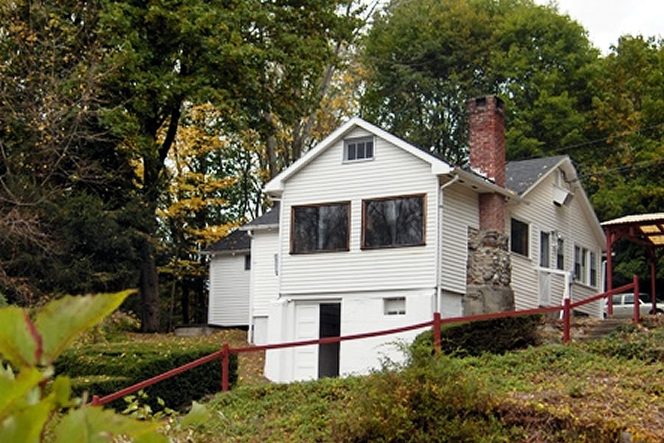
$215,000 (SOLD)

Style: Ranch Bedrooms: 2

Stories: 1 Bathrooms: 1

Square Feet: 924 Great Room: 22’ x 13’

Lot Size: 1.8 acres Kitchen: 11’ x 10’
Year Built: 1950 Den: 11’ x 10’
Taxes: $2,789 (2005) Bedroom: 11’ x 10’
Exterior: Vinyl Bedroom: 14’ x 12’
Roof: Asphalt Shingle CCND MLS: #61382
Heat: Electric Mid-Hudson MLS: #236937

This home has Ten Mile River frontage, 300 feet, with wonderful fishing and bird watching. The Great Blue Herons are often seen fishing, soaking in the sun and flying along the river. The flowing river water is soothing to watch and hear, but the access is exhilarating. This single floor home has 2 good-sized bedrooms and a den all with hard wood floors. The living room and dining area share a fireplace with a woodstove insert and beamed ceilings. This home was mostly used as a summer retreat, but the electric heating system allows for year round use. All of this is located with in minutes of Metro North, State Parks, Golf and the Harlem Valley Rail Trail.

The real estate data for sale on this website is subject to errors, omissions, changes, and withdrawal without notice. Information deemed to be reliable but not guaranteed.

