
3298 Route 343 (East Main Street) PO Box 15 Amenia, New York 12501-0015
TEL: 845.373.8555 FAX: 845.373.9850 eMail: havensre@verizon.net
www.havensre.com

Licensed Real Estate Broker

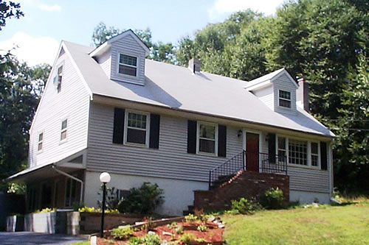 | Serenity in Stanfordville  67 Tick Tock Way  Stanfordville, New York  Spacious 3 bedroom, 2.5 bath Cape with 3 versatile and charming living levels. Over 2,800 square feet of living space. Handsome hardwood floors, stunning brick fireplace, wonderful private yard and an in-ground pool. Tic Tock Way is a quiet cul-de-sac away from the busy noisy roads. Living Room with fireplace combined with the Dining Room creates one large room (25’3” x 13’).  Price: $349,000 (SOLD)


Style: | Cape | Bedrooms: | 3
Stories: | 3 | Living Room: | 13 x 12’3” w/ FP
Square Feet: | 2,820 | Dining Room: | 13 x 13
Lot Size: | 1.1 acres | Kitchen: | 26 x 12
Year Built: | 1973 | Master Bedroom: | 13 x 12
Taxes: | $4,809.00 (2005) Star | Family Room: | 24 x 12
Exterior: | Vinyl | Bedroom #1: | 12 x 11
Driveway: | Blacktop | Bedroom #2/Den: | 11 x 11
Heat: | BBHW, Oil | Baths: | 2.5

Additional:
Pool: 25x18 in-ground
Bonus Rooms include a home office with a private waiting room at ground level and a Family Room that is 24’ x 12’.

The real estate data for sale on this website is subject to errors, omissions, changes, and withdrawal without notice. Information deemed to be reliable but not guaranteed.

