
Licensed Real Estate Broker
3300 Route 343 (East Main Street) PO Box 15 Amenia, New York 12501-0015
TEL: 845.373.8555 FAX: 845.373.9850 eMail: havensre@optonline.net
www.havensre.com

Handy Person Needed
66 Ernest Rd, Town of Stanford, NY
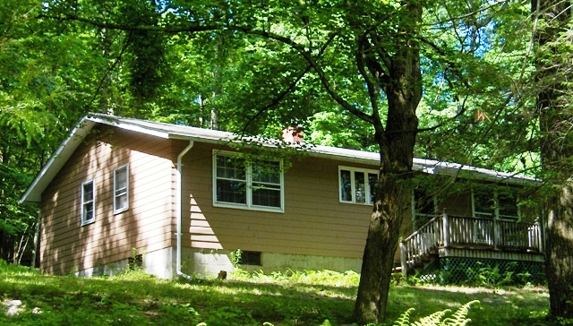
$179,000 (SOLD)

Style: Ranch Bedrooms: 4 Bathrooms: 1.5

Stories: 1 Living Room: 19’ x 13’

Square Feet: 1,260 Kitchen: 13’ x 11’

Lot Size: 4.8 acres Bedroom: 13’ x 11’
Year Built: 1970 Bedroom: 11’ x 10’
Taxes: $4255 w/ no exemptions Bedroom: 10’ x 9’
Exterior: Clapboard Bedroom: 13’ x 11’
Roof: Asphalt Shingle CCND MLS: #77598
Electric: 100 Amps, circuit breakers Mid-Hudson MLS: #288634
Heat: Forced Hot Air Oil Fired

A special setting for this single floor home that will need a few finishing touches. The 4 acres is deep and overgrown but with some clearing you will develop a gorgeous backyard. The roof has been replaced, the septic has been replaced, the furnace has been replaced and there is a fairly new 100 AMP electrical service. With a little creativity and sweat equity this home will make an excellent family residence.

The real estate data for sale on this website is subject to errors, omissions, changes, and withdrawal without notice. Information deemed to be reliable but not guaranteed.

