
Licensed Real Estate Broker
3300 Route 343 (East Main Street) PO Box 15 Amenia, New York 12501-0015
TEL: 845.373.8555 FAX: 845.373.9850 eMail: havensre@verizon.net
www.havensre.com

Walk to Everything
63 Mill Street, Town of Dover, New York
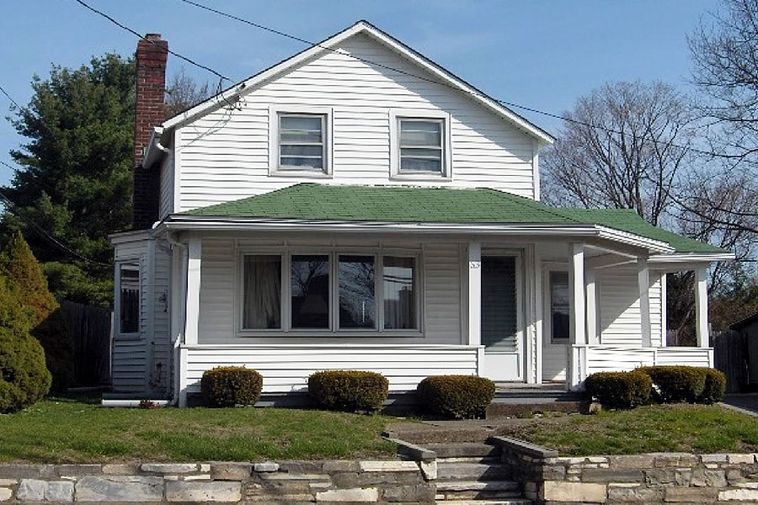
$205,000 SOLD

Style: Village Home Bedrooms: 2

Stories: 2 Bathrooms: 1

Square Feet: 934 Living Room: 13’ x 12’

Lot Size: .16 acres Kitchen: 22’ x 9’
Year Built: 1867 Dining: 16’ x 11’
Taxes: $2,901 (2006) Bedroom: 13’ x 12’
Exterior: Vinyl Bedroom: 12’ x 10’
Roof: Asphalt Shingle, Rolled CCND MLS: #62869
Heat: Oil fired hot Water Mid-Hudson MLS: #242119

This home has been owned and occupied by the same family since 1947. Treated with dignity this charming home is surprising in size and the rooms are filled with sunlight. There is some updating that needs to be done but this is perfect for those just starting out or scaling back. Completing the package is a delightful front porch, a quaint and level back yard with an oversized garage.
All of this is located with in minutes of Metro North, State Parks, Golf and the Harlem Valley Rail Trail.
The real estate data for sale on this website is subject to errors, omissions, changes, and withdrawal without notice. Information deemed to be reliable but not guaranteed.

