
Licensed Real Estate Broker
3300 Route 343 (East Main Street) PO Box 15 Amenia, New York 12501-0015
TEL: 845.373.8555 FAX: 845.373.9850 eMail: havensre@verizon.net
www.havensre.com

Cute and Cozy
6055 Route 22, Millerton, New York
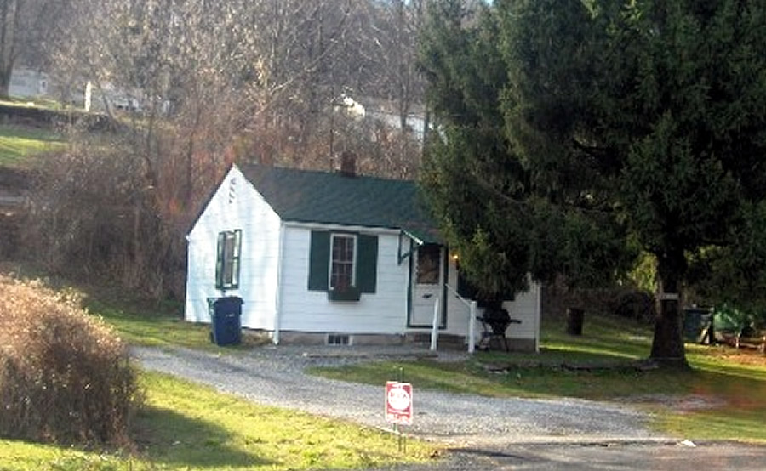
$139,000 Now $129,000 SOLD

Style: Cottage Bedrooms: 1
Stories: 1 Bathrooms: 1 Full

Square Feet: 528 Living Room: 12” x 13’
Lot Size: 0.24 acres Kitchen: 12’ x 13”
Year Built: Bedroom #1: 12’ x 12’
Taxes: $1,264 (2005)
Heat: Extremely Efficient Electric

Cute and cozy house has living room, spacious eat-in kitchen, 1 bedroom and 1 bath. Extremely convenient to town, state parks, antiquing, movie theatre, Harlem Valley Rail Trail and only 12 miles from the Metro North Train Station. All recently renovated including windows, laminated floors, kitchen, bath, electric, heat, and roof. House is a great starter, retirement or weekend retreat.

The real estate data for sale on this website is subject to errors, omissions, changes, and withdrawal without notice. Information deemed to be reliable but not guaranteed.

