
Licensed Real Estate Broker
3298 Route 343 (East Main Street) PO Box 15 Amenia, New York 12501-0015
TEL: 845.373.8555 FAX: 845.373.9850 email: havensre@verizon.net
www.havensre.com

Classic Village of Millerton Home
5887 S Elm Ave, Millerton New York
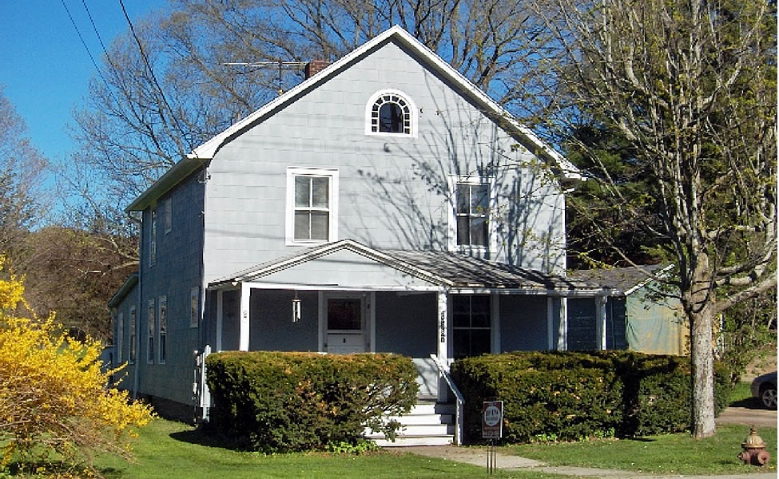
$169,000 (SOLD)

Style: Village 2 story Bedrooms: 3

Stories: 2 Bathroom: 1.5

Square Feet: 1,508 Living Room: 13’ x 12’

Lot Size: 0.75 acres Kitchen: 13’ x 9’

Year Built: Early 1900’s Dining Room: 13’ x 14’
Taxes: $3,425 no exemptions (2008) Family Room: 14’ x 12’
Heat: Steam Bedroom #1: 12’ x 11’
Exterior: Asbestos Bedroom #2: 11’ x 10’
Roof: Asphalt Shingle Bedroom #3: 11’ x 10’
Electric: Fuses CCNDMLS# 66358
Additional: Front Porch & Big Back Yard MHMLS # 254650
The rocking chair front porch invites you to go back in time. This sweet old style home needs just a little extra care however it is graced with light, charm and dignity. Well balanced rooms, each with wood floors, each with at least a couple of windows and high ceilings. Genuine moldings and doors add character and would be very difficult to replicate. The yard is long, level and lush, plenty of room for the family outing. The excitement of Eastern Dutchess County is just minutes away. New Assessment $166,000.
The real estate data for sale on this website is subject to errors, omissions, changes, and withdrawal without notice. Information deemed to be reliable but not guaranteed.

