
3298 Route 343 (East Main Street) PO Box 15 Amenia, New York 12501-0015
TEL: 845.373.8555 FAX: 845.373.9850 eMail: havensre@verizon.net
www.havensre.com

Licensed Real Estate Broker

Excellent Millerton Location

5877 Elm Ave., Millerton, New York

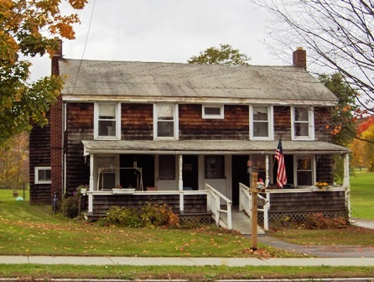
$149,000 (SOLD)

Style: 2-Family Zoning: R 2000

Stories: 2 Income: $15,600

Square Feet: 2,400 Expenses: $ 4,620

Lot Size: 1.2 acres Taxes: $2,773 (2004)
Year Built: 1900
Exterior: Cedar Shake
Heat: Forced Hot Air Oil Fired
Utilities: Each Unit has its own Furnace, Oil Tanks, Hot Water Heater, Electrical Service

A convenient Millerton location. Walking distance to village shops, movie theaters, and the Rail Trail. 12 miles to the Wassaic train station and only minutes to state park. This 2-family home is fully rented and in need of a few repairs. The house needs a roof. Please call for an appointment and please try to remember that I need to give the tenants sufficient notice.

The real estate data for sale on this website is subject to errors, omissions, changes, and withdrawal without notice. Information deemed to be reliable but not guaranteed.

