574 Carson Road, Ancram, NY

Licensed Real Estate Broker
3298 Route 343 (East Main Street) PO Box 15 Amenia, New York 12501-0015
TEL: 845.373.8555 FAX: 845.373.9850 eMail: havensre@verizon.net
www.havensre.com

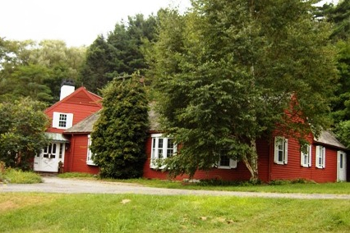

$599,000 (SOLD)

Style: Farm House Bedrooms: 5 Baths: 4

Stories: 2 Living Room: 27' x 15'

Square Feet: 2,492 Dining Room: 14'6 x 13'6

Lot Size: 12 acres Kitchen: 16' x 10'
Year Built: 1830 Gathering Room: 10'4 x 10’
Taxes: $8,816 w/no exemption Master Bedroom: 15’ x 15’
Exterior: Clapboard Bedroom: #2: 15’ x 11’
Garage: 3 bay garage w/studio Bedroom: #3: 15’ x 10’
Heat: Forced Hot Air (HVAC System) Bedroom: #4 13’x 8’
Den/Office: 14'6 x 10’ Bedroom: #5 12’6” x 10’

This farmhouse has grown over the years and the updates have made it very comfortable inside and out. The plantings are special, the pond and stream are what everyone is looking for. With 5 bedrooms and 4 baths and 2 handsome fireplaces, this home welcomes you immediately. The lodge type living room embraces you and the other living spaces are engaging.

The real estate data for sale on this website is subject to errors, omissions, changes, and withdrawal without notice. Information deemed to be reliable but not guaranteed.

