
3298 Route 343 (East Main Street) PO Box 15 Amenia, New York 12501-0015
TEL: 845.373.8555 FAX: 845.373.9850 eMail: havensre@verizon.net
www.havensre.com

Licensed Real Estate Broker

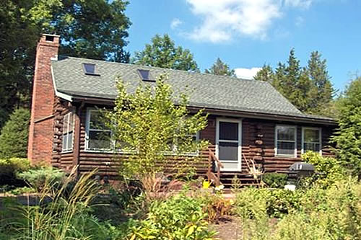 | Cozy and Private  55 Red Cedar Lane  Millerton, New York  An incredible retreat is nestled in a wooded glen with rewarding privacy. This property is part of the Indian Lake Homeowners Association and itsﬂ benefits include lake rights, tennis court use and maintaining the private roads. This cozy and charming home features a brick fireplace, exposed beams, cathedral ceiling, sky lights, hardwood floors and a serene enclosed porch (19’9”x7’2” included in square footage). The country life located just 3 miles from the Village of Millerton and just minutes to the Wassaic train station.  Price: SOLD


Style: | Log Cabin | Bedrooms: | 2
Stories: | 1.5 | Bathrooms: | 1
Square Feet: | 900 | Living Room: | 15'8" x 13"
Lot Size: | 1.48 acres | Dining Room: | 12'8" x 7'2"
Year Built: | 1973 | Kitchen: | 12'8" x 7'2"
Floors: | HardWood | Family Room:
Basement: | Full unfinished | Master Bedroom: | 15 x 13
Garage: | None | Bedroom #1 | 13 x 12'6"
Heat: | Electric,  Fireplaces: 1 in Living Rm.
Additional:
Listing: MHMLS #2226107 CC/ND MLS #57918

The real estate data for sale on this website is subject to errors, omissions, changes, and withdrawal without notice. Information deemed to be reliable but not guaranteed.

