D

Licensed Real Estate Broker

Minutes to Kent, CT
522 Bog Hollow Rd. Wassaic, New York
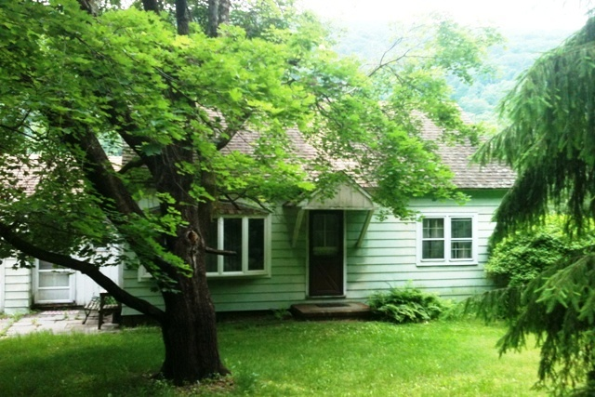
SOLD

Style: Cape Bedrooms: 2

Stories: 2 Bathrooms: 1

Square Feet: 1152 Living Room: 17’ x 11’

Lot Size: 2.8 acres Kitchen: 16’ x 10’
Year Built: 1954 Master Bedroom 11’ x 11’
Taxes: $3994. (2012) Bedroom: 11’ x 10’
Exterior: Aluminum Upstairs Room #1 23’ x 11’
Roof: Asphalt Shingle Upstairs Room #2 14’ X 15”
Heat: Forced Hot Air / Oil Mid-Hudson MLS: #308031
CCND MLS: #85369

This 1954 Cape has lots of potential. The home has wood floors throughout. There are two bedrooms, eat in kitchen, living room, full bathroom, and dining area with sliders to the back deck which over looks the pond, and the beautiful mountain views. There are also two more rooms upstairs that were used as bedrooms.

The real estate data for sale on this website is subject to errors, omissions, changes, and withdrawal without notice. Information deemed to be reliable but not guaranteed.

3300 Route 343 (East Main Street) PO Box 15 Amenia, New York 12501-0015
TEL: 845.373.8555 FAX: 845.373.9850 email: havensre@optonline.net
www.havensre.com

