5118 Route 22, Amenia, New York
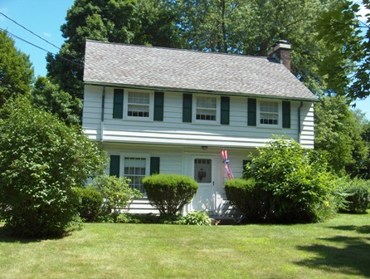

Licensed Real Estate Broker
3298 Route 343 (East Main Street) PO Box 15 Amenia, New York 12501-0015
TEL: 845.373.8555 FAX: 845.373.9850 eMail: havensre@verizon.net
www.havensre.com
$279,000 (SOLD)

Style: Colonial Bedrooms: 3

Stories: 2 Baths: 1 Full, 1 Half

Square Feet: 1432 Living Room: 21’ x 12’ with Fireplace

Lot Size: .57 acres Dining Room: 13’ x 11’
Year Built: 1942 Kitchen: 14’ x 8’
Taxes: $3439 (2005) Breakfast Nook 8’ x 7’
Exterior: Clapboard Bedroom: #1: 18’ x 10’
Garage: Detached 2 car Bedroom: #2: 14’ x 10’
Heat: Radiator oil fired Bedroom: #3: 12’ x 9’

Filled with style and comfort the 1943 colonial was built to last and is extremely appealing. This home features rooms that are generous in size and hardwood floors throughout together with the fireplace in the living room have combined to make this home very appealing. Located outside the Hamlet of Amenia this charming home is extremely convenient to Metro North, State Parks, and Golf. Boiler, septic, roof and electric were recently updated.

The real estate data for sale on this website is subject to errors, omissions, changes, and withdrawal without notice. Information deemed to be reliable but not guaranteed.

