Licensed Real Estate Broker

A Sweet Country Home
5100 Route 22, Amenia, New York
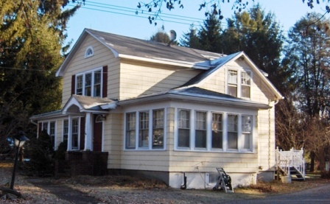
$189,000 Reduced to: $169,000 (SOLD)

Style: Traditional Bedrooms: 3

Stories: 2 Baths: 1.25

Square Feet: 1,720 Living Room: 23’ x 14’

Lot Size: .6 acre Dining Room: 15’ x 11’
Year Built: 1900 Kitchen: 12’ x 12’
Taxes: $4,106 Breakfast Nook: 8’ x 6’
Exterior: Shake Bedroom: #1: 16’ x 11’
Roof: Asphalt Shingle Bedroom: #2: 13’ x 9’
Garage: over size 2 car detached Bedroom: #3: 12’ x 9’
Heat: Oil Fired Hot Water CCNDMLS: #82821
MHMLS: #303435
Filled with character and charm this very appealing home is all you will ever need in a country home. The wood floors and moldings are so handsome and each room the offers cheerful characteristics and special spaces. A really nice deck overlooks the level yard that is perfect for gardening and the oversized 2 car garage is unlimited in its potential. Metro North, the Harlem Valley Rail Trail, Golf, State Parks, Sharon Hospital and several schools are all very convenient to this home.
3298 Route 343 (East Main Street) PO Box 15 Amenia, New York 12501-0015
TEL: 845.373.8555 FAX: 845.373.9850 email: havensre@optonline.net
www.havensre.com
The real estate data for sale on this website is subject to errors, omissions, changes, and withdrawal without notice. Information deemed to be reliable but not guaranteed.

