
Licensed Real Estate Broker
3298 Route 343 (East Main Street) PO Box 15 Amenia, New York 12501-0015
TEL: 845.373.8555 FAX: 845.373.9850 eMail: havensre@verizon.net
www.havensre.com

4 Upper Main St, #1 Sharon Green
Sharon, CT
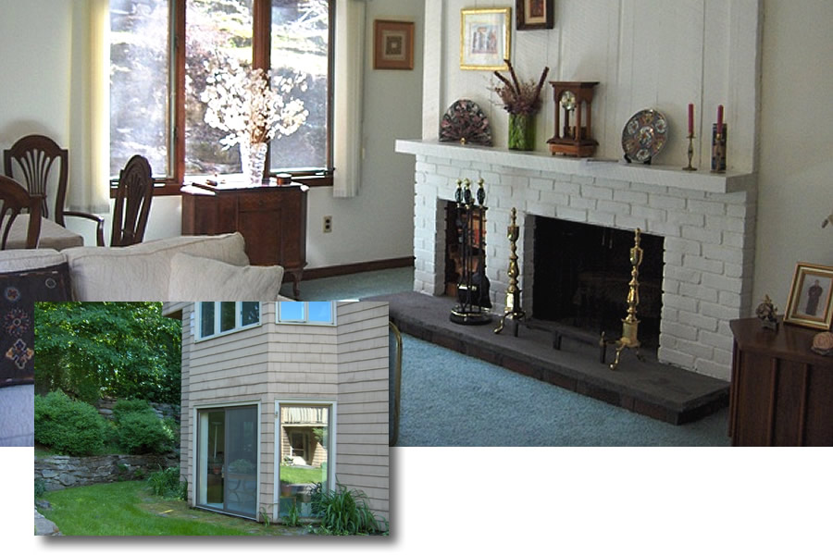
$229,000

Style: Condominium Bedrooms: 2 Bathrooms: 2

Stories: One, End Unit Living Room: 22’ x 16’

Square Feet: 1,040 Kitchen: 9’ x 9’

Year Built: 1973 Dining Area: 13’ x 10’
Taxes: $1,615 (2006) Master Bedroom: 14’ x 12’
Exterior: Cedar Bedroom: 12’ x 10’
Heat / AC: Heat Pump/ Central Air CCND MLS: #65999
Electric: 200 Amps, circuit breakers Mid-Hudson MLS: #252733

A fabulous first floor end unit that is just a bit more private than most with charming rooms filled with natural light. A manageable size offering areas for all of life’s necessities; enough walls for hanging or growing, and rooms of generous proportions with floor space for just about everything. This home provides for all the comforts and none of the challenges. Just a short walk or drive to scores of activities. Metro North is about 8 miles away. New England is at your front door!
The real estate data for sale on this website is subject to errors, omissions, changes, and withdrawal without notice. Information deemed to be reliable but not guaranteed.

