
Licensed Real Estate Broker

Amenia Charmer
472 Leedsville Road, Amenia, NY
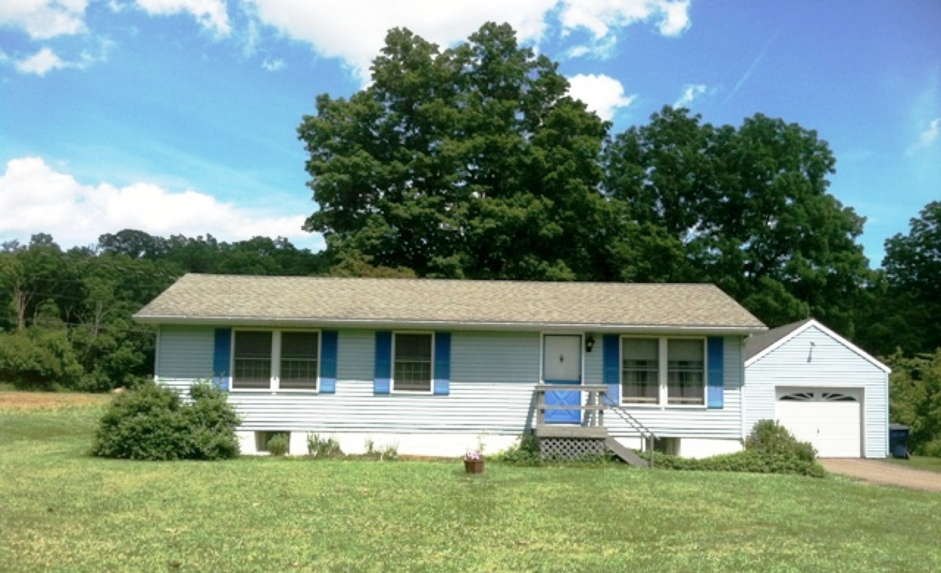
$179,000 Now $169,000 (SOLD)

Style: Ranch Bedrooms: 3 Bathrooms: 1

Stories: 1 Living Room: 16’ x 8’ w/ Dining Area

Square Feet: 1,056 Kitchen: 11’ x 8’

Lot Size: .47 acre Bedroom: 13’ x 11’
Year Built: 1984 Bedroom: 13’ x 8’
Taxes: $2,677 Bedroom: 11’ x 8’
Exterior: Vinyl Garage: 1 car detached
Roof: Shingle (2003) Heat: Baseboard Electric
Electric: 200 Amps Enclosed Porch: 15’ x 12’ w/ Pellet Stove
MHMLS: #306787 CCNDMLS: # 84727

This fabulous Amenia home is a wonderful opportunity because of its special charm and immaculate condition. A home like this in this amazing rural countryside could be your dream comes true. 3 bedrooms, an open Kitchen, Dining, Living Room offering outstanding space yet cozy and manageable. Minutes to Sharon, CT, Wassaic Train Station and all of the bounties of the area’s farms and farm markets.
The real estate data for sale on this website is subject to errors, omissions, changes, and withdrawal without notice. Information deemed to be reliable but not guaranteed.
3300 Route 343 (East Main Street) PO Box 15 Amenia, New York 12501-0015
TEL: 845.373.8555 FAX: 845.373.9850 email: havensre@optonline.net
www.havensre.com

