
Licensed Real Estate Broker
3298 Route 343 (East Main Street) PO Box 15 Amenia, New York 12501-0015
TEL: 845.373.8555 FAX: 845.373.9850 email: havensre@optonline.net
www.havensre.com

Totally Accessible
46 Hoags Corners Road, Town of Dover
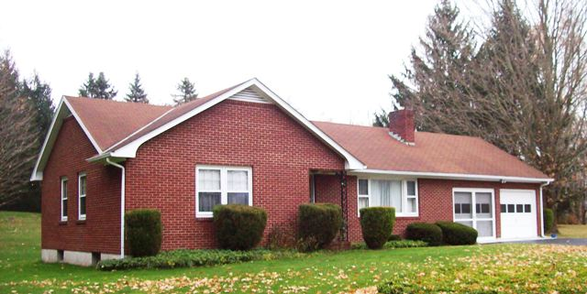
$210,000 (SOLD)

Style: Ranch Bedrooms: 2 Bathrooms: 1

Stories: 1 Living Room: 19’ x 12’ w/ FP

Square Feet: 1,184 Kitchen: 22’ x 20’

Lot Size: .92 acres Master Bedroom: 16’ x 15’
Year Built: 1965 Bedroom: 11’ x 11’
Taxes: $4,918 (2013) w/ no exemptions Basement: Full and useable
Exterior: Brick Roof: Asphalt Shingle
Electric: 100 Amps, fuses CCND MLS: #94016
Heat: Hot air oil Mid-Hudson MLS: #321736

The perfect location and setting for this extraordinary custom built 2 bedroom brick home and property. Hard wood floors through out! Aesthetically pleasing yard adorned with ever blossoming mature plantings and plenty of room for pets and gardens. The out of doors is an extension of this well cared for home. There is extremely easy access to Route 22 to travel both North or South, the Wingdale Metro North Station and Pleasant Ridge Road that connects Eastern Dutchess with Central Dutchess County. You can walk to the Harlem Valley Golf Coarse.
The real estate data for sale on this website is subject to errors, omissions, changes, and withdrawal without notice. Information deemed to be reliable but not guaranteed.

