
Licensed Real Estate Broker

Filled with character and charm
46 Dutchess Avenue, Millerton, New York
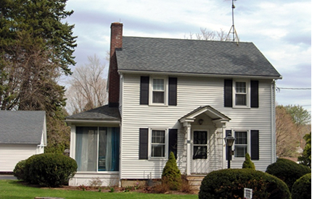
SOLD

Style: Colonial Bedrooms: 3

Stories: 2 Baths: 1.25

Square Feet: 1,554 Living Room: 23’ x 12’ w/ Fireplace

Lot Size: .44 acre Dining Room: 12’ x 11’
Year Built: 1927 Kitchen: 12’ x 11’
Taxes: $4,220 Sun Room: 11’ x 7’
Exterior: Aluminum Bedroom: #1: 13’ x 12’
Roof: Asphalt Shingle Bedroom: #2: 13’ x 9’
Garage: 2 car detached Bedroom: #3: 10, x 9’
Heat: Fired Hot Steam Family Room: 20’ x 12’

Filled with character and charm this handsome well built Village of Millerton home is in move in condition. The roof, many of the windows and the septic has all been replaced. The back yard is ideal for gardening or a play area. A variety of interesting shops, Movie Theater, local farm stands and exceptional restaurants are located just minutes away from this quiet location on a fine Village Street. Metro North, the Harlem Valley Rail Trail, Golf, State Parks, Eddie Collins Field and the Denney Pool are all very convenient.

The real estate data for sale on this website is subject to errors, omissions, changes, and withdrawal without notice. Information deemed to be reliable but not guaranteed.
3300 Route 343 (East Main Street) PO Box 15 Amenia, New York 12501-0015
TEL: 845.373.8555 FAX: 845.373.9850 email: havensre@optonline.net
www.havensre.com

