
Licensed Real Estate Broker
3300 Route 343 (East Main Street) PO Box 15 Amenia, New York 12501-0015
TEL: 845.373.8555 FAX: 845.373.9850 eMail: havensre@optonline.net
www.havensre.com

Walk with ease to the Village of Millerton center
41 South Maple Ave, Millerton, NY
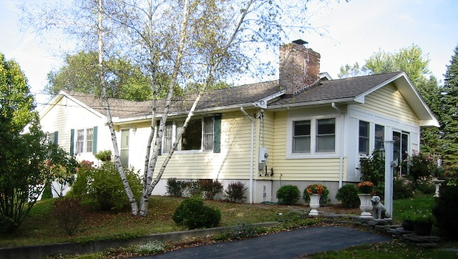
$349,000 (SOLD)

Style: Ranch Bedrooms: 3 Bathrooms: 1.5

Stories: 1 Living Room: 23’ x 12’ w/FP

Square Feet: 2,125 Kitchen: 14’ x 13’

Lot Size: 1 acre Dining Area: 13’ x 12’
Year Built: 1976, remodeled in ’03-‘04 Master Bedroom: 12’ x 12’
Taxes: $3,245 Bedroom: 12’ x 12’
Exterior: Vinyl Bedroom: 12’ x 12’
Roof: Architectural Shingle Family Room: 19’ x 10’
Electric: 200 Amps, w/generator Mid-Hudson MLS: #262902
Heat: BBHW CCND MLS: #69144

This well built home has been painstakingly remodeled and great care was given to creating charm and style by using only quality materials and thoughtful planning. The kitchen is exquisite, the sun room is extraordinary, and the living room is filled with natural light and adorned with spectacular wood floors and a brick fireplace. Amenities include: 6 zone high efficiency heating system, 200 AMP electric service and a 10,000 watt generator that can run practically the entire house, custom designed kitchen with a ceramic tile floor, stone counters and stainless appliances, upgraded baths with ceramic tile floors, architectural shingle roof (’03), sun deck, screened gazebo with electric, flagstone walks and patio, greenhouse and gardens, extensive shrubbery and mature trees, wiring for an invisible fence, alarm system, lower level office or family room with a separate entrance and a one car garage.

The real estate data for sale on this website is subject to errors, omissions, changes, and withdrawal without notice. Information deemed to be reliable but not guaranteed.

