
Licensed Real Estate Broker

Affordable Housing
3 Prospect Avenue, Amenia, NY
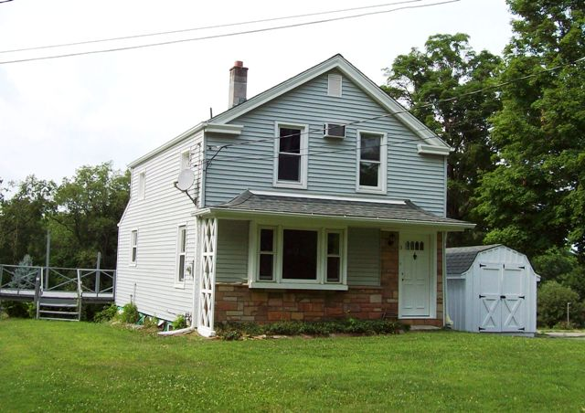
SOLD

Style: Village Colonial Bedrooms: 2 Bathrooms: 1.5

Stories: 2 Living Room: 15’ x 12’

Square Feet: 1,060 Kitchen: 13’ x 9’

Lot Size: .62 acre Bathroom: 10’ x 4’
Year Built: 1890 Bedroom: 12’ x 11’
Taxes: $2,818 Bedroom: 8’ x 8’
Exterior: Vinyl Heat: BBHWO
Roof: Asphalt Shingle (NEW) MH MLS: #328059
Electric: 100 Amps CCND MLS: #96879

Completely remodeled! Sit back and relax and enjoy the comforts of the great deck and fabulous yard. There is nothing to do: new roof, new kitchen, new floors, new wainscoting, and freshly painted interior. Out with the old! In with the new! My goodness what a difference. Beautiful, just beautiful! This home is conveniently located on a side street in Amenia and just minutes from The Wassaic Train Station in one direction and Sharon, Ct in the other.

The real estate data for sale on this website is subject to errors, omissions, changes, and withdrawal without notice. Information deemed to be reliable but not guaranteed.
3300 Route 343 (East Main Street) PO Box 15 Amenia, New York 12501-0015
TEL: 845.373.8555 FAX: 845.373.9850 email: havensre@optonline.net
www.havensre.com

