
Licensed Real Estate Broker
3298 Route 343 (East Main Street) PO Box 15 Amenia, New York 12501-0015
TEL: 845.373.8555 FAX: 845.373.9850 eMail: havensre@verizon.net
www.havensre.com

TLC Required
366 Winchell Mt. Road, Town of North East, New York
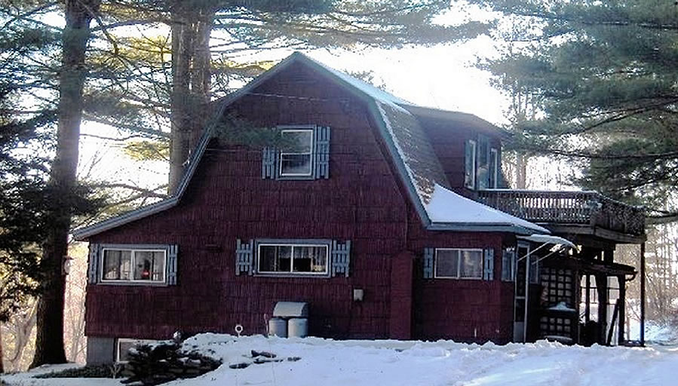
$179,000 (SOLD)

Style: Dutch Colonial Bedrooms: 2

Stories: 2 Bathrooms: 1

Square Feet: 750 Living Room: 15’ x 9’6”

Lot Size: 1 acre Kitchen: 15’ x 10’6”
Year Built: 1932 Dining Area: 12’ x 5’8”
Taxes: $2,396 (2005) Bedroom: 11’ x 9’4”
Exterior: Cedar Shake Bedroom: 11’ x 10’3”
Roof: Asphalt Shingle CCND MLS: #61818
Heat: Forced Hot Air oil Mid-Hudson MLS: #238493

Nestled in a glen of mature trees, many are towering pines that whisper in the wind, this cozy 2 story cottage sits in a serene setting with surprising privacy. This is the perfect opportunity to fix up a place to call home. The quaint tree house makes a nice little studio or workshop. The Village of Millerton is just down the road. Metro North, State Parks, Golf and the Harlem Valley Rail Trail, fine restaurants and the Movie House are all within minutes of this home.
Directions: From Millerton – North on Route 22 to Left on Winchell Mountain Road to house on the Left. # 366.

The real estate data for sale on this website is subject to errors, omissions, changes, and withdrawal without notice. Information deemed to be reliable but not guaranteed.

