
Licensed Real Estate Broker

3 Story Commercial Space
3330 Route 343, Amenia, New York
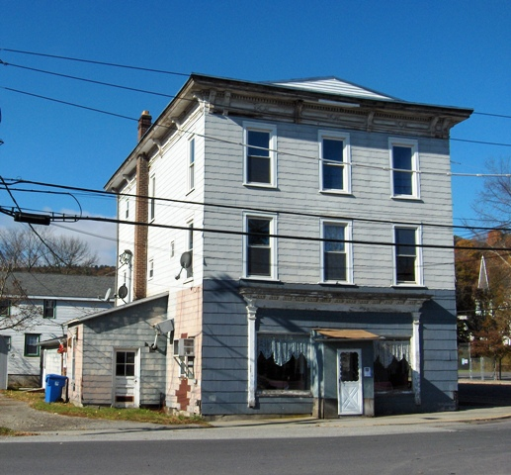
SOLD

Style: Building Frame Zoning: Hamlet Mixed Use

Stories: 3

Square Feet: 5,670 Town Water & Private Septic
Lot Size: .25 acres Exterior: Asbestos
Year Built: 1920 Heat: Oil Baseboard
Taxes: $5,508 (2008)

This 3 Story commercial space is located on the corner of Rt. 343 and Mechanic Street in Hamlet of Amenia. This Historic building has three (3) apartments. Two Apartments rented at this time. There is an Antique Store on first level as of February 1st, 2009. Also additional space on first level available is for rent. Large 3rd floor space for added rental with Town building inspector approval.

Call A. J. Hayes at 845 702 2770 for details and appointment. 24 hours notice to show.

The real estate data for sale on this website is subject to errors, omissions, changes, and withdrawal without notice. Information deemed to be reliable but not guaranteed.
3300 Route 343 (East Main Street) PO Box 15 Amenia, New York 12501-0015
TEL: 845.373.8555 FAX: 845.373.9850 email: havensre@optonline.net
www.havensre.com

