Historical Significance
331 Merwin Road, Millerton, New York
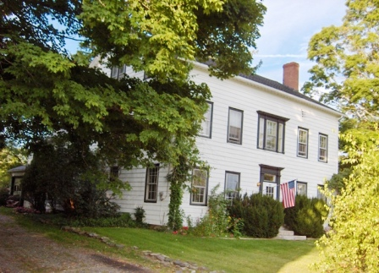
$399,000 Now: SOLD

Style: Colonial Bedrooms: 5 *

Stories: 3 Baths: 2 Full

Square Feet: 2,788 2 Living Rooms: 17’ x 14” 19’ x 14’

Lot Size: 1 acre 2 Dining Room: 16’ 4”x 10’7” 16’6” x 12’3”
Year Built: 1820 2 Kitchen: 11’ x 10’
Taxes: $6,127 Bedrooms 1st floor: 15’ x 8’3” 15’ x 7’8”
Exterior: Asbestos Bedrooms 2nd floor: 14’10” x 8’3” 14’10” x 7’8”
Fireplace: 1st floor 2nd fl unheated rooms: 15’6” x 13’ 14’9” x 8”
Garage: 2 car attached 3rd floor unheated rooms: 5 rooms, 1,368 sq ft
Heat: Steam Radiators Oil

Licensed Real Estate Broker

If these walls could talk? History has been kind to this 1820 Center Hall Colonial as it still stands proud and about as true as the day it was built. A private home for many years, later converted to a Stage Stop, and sometime in the 20th Century converted into a 2 family home. At present about 2,788 sq ft is heated and divided into 2 apartments. 2046 sq ft (2 rooms on the 2nd floor and the entire 3rd floor) are not heated but in nearly move-in condition. The possibilities are extraordinary. The wide board floors in the apartments have been covered by carpets, the ceilings are high and the large windows are filled with sun. The original 3 story mahogany stair case still adorns the center of this incredible building. Located just outside the Village of Millerton and just 15 miles to the Wassaic Train Station. Golf, skiing, antiquing all nearby.

The real estate data for sale on this website is subject to errors, omissions, changes, and withdrawal without notice. Information deemed to be reliable but not guaranteed.
3300 Route 343 (East Main Street) PO Box 15 Amenia, New York 12501-0015
TEL: 845.373.8555 FAX: 845.373.9850 email: havensre@optonline.net
www.havensre.com

