
Licensed Real Estate Broker

2 Family - Amazing Opportunity
331 Merwin Road, Millerton New York
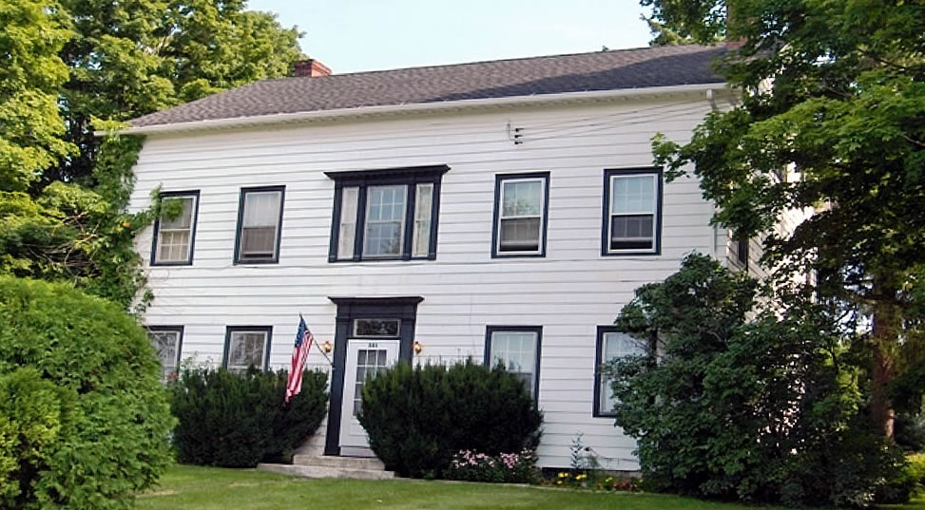
$399,000 Now: SOLD

Style: Two Family Bedrooms Unit 1: 15 x 8’3”; 15 x 7’8”

Zoning: R1A Bedrooms Unit 2: 14’10” x 8’3”; 14’10” x 7’8”

Square Feet: 1,394 each unit Bathrooms: 1 each unit

Lot Size: 1 acre Living Room #1: 17’ x 14’ w/ Fireplace
Year Built: 1820 Living Room #2: 19’2”’ x 14’
Taxes: $6127 Kitchen #1: 16’4” x 13’
Exterior: Asbestos Kitchen #2: 16’ 6” x 15’10”
Roof: Asphalt Shingle (new) CCND MLS: #67826
Heat: Steam Oil fired Mid-Hudson MLS: #258629

This 1820 Center Hall Colonial features an impressive 3 story mahogany staircase with a past that could fill history books. Now this exceptional 2 family home awaits a new landlord or owner occupant. In addition to the rooms listed above each floor is blessed by a gracious dining room (The 2nd floor DR is usually used as the master bedroom, the natural light is magnificent). The 2nd floor also has 2 unheated rooms (652) that will adapt on demand. The 3rd floor is readily accessible from the 2nd flr and that space (1394 sq ft) is outstanding. Freshly painted, this level is simply extraordinary. Ideal but not limited to studio, workshop, or home office. Located about half way between Rudd Pond and the Village of Millerton, the setting is serine the views are bucolic, the opportunity is amazing.

The real estate data for sale on this website is subject to errors, omissions, changes, and withdrawal without notice. Information deemed to be reliable but not guaranteed.
3298 Route 343 (East Main Street) PO Box 15 Amenia, New York 12501-0015
TEL: 845.373.8555 FAX: 845.373.9850 email: havensre@optonline.net
www.havensre.com

