
3298 Route 343 (East Main Street) PO Box 15 Amenia, New York 12501-0015
TEL: 845.373.8555 FAX: 845.373.9850 eMail: havensre@verizon.net
www.havensre.com

Licensed Real Estate Broker

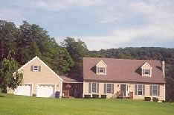 | Breathtaking Vista  32 Yellow City Road  Amenia, NY 12501  Impeccably maintained cape inside and out with breathtaking vistas. Sunny spacious rooms are filled with country charm. The breezeway and large deck add additional seasonal floor space. An oversized garage with walk up attic area is unbelievably useful. 3/4 bedrooms, 2 baths on 1.38 acres.  Price: SOLD  Tax: $4098  School: Webutuck
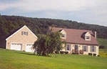

Style: | Cape | Bedrooms: | 3
Stories: | 2 | Living Room: | 16' x 12'
Square Feet: |  | Dining Room: | 12' x 11'
Lot Size: | 1.38 acres | Kitchen: | 17' x 12'
Year Built: |  | Master Bedroom:
Floors: |  | Bedroom #1: | 19' x 15'
Basement: |  | Bedroom #2: | 12' x 10'
Garage: | Oversized garage  w/ walk up attic area | Den/Bedroom #3: | 14' x 12'
Heat: |  | Baths: | 2

Additional:
Den/Office: 10' x 10'
Possible 4th bedroom
Other Room: Breezeway 13' x 12'

