
3298 Route 343 (East Main Street) PO Box 15 Amenia, New York 12501-0015
TEL: 845.373.8555 FAX: 845.373.9850 eMail: havensre@verizon.net
www.havensre.com

Licensed Real Estate Broker

Mason's Building

3296 Route 343, Amenia, New York

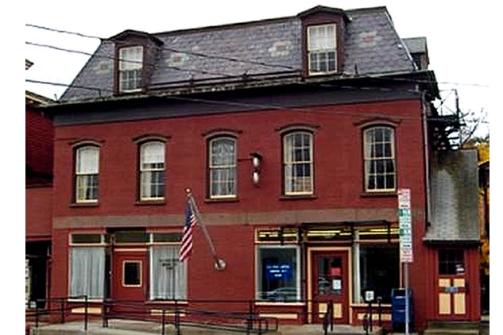
$295,000 (SOLD)

Style: 3 Story Brick Zoning: General Business

Stories: 3 Levels Income: $17,400 (2004)

Square Feet: 5,400 Expenses: $15,246

Lot Size: .07 acres Taxes: $4,878 (2004)
Exterior: Brick
Year Built: 1900
Heat: Radiator Steam Oil Fired

Known as the Mason's Building or the Masonic Lodge this incredible building dates back to 1900. There are 3 levels. Floors 2 and 3 are now being used as meeting rooms for the Amenia Lodge 672 F & AM. These are large rooms with enormous possibilities. The first floor is the home of the Amenia Post Office and Havens Real Estate. This Main Street location has good visibility and is equipped with a handicap accessible ramp to the Post Office. The future of the 300-year-old Town of Amenia is linked to buildings like this. Their unspoiled character powers these historical monuments and many distinguished features.

The real estate data for sale on this website is subject to errors, omissions, changes, and withdrawal without notice. Information deemed to be reliable but not guaranteed.

