
Licensed Real Estate Broker
3300 Route 343 (East Main Street) PO Box 15 Amenia, New York 12501-0015
TEL: 845.373.8555 FAX: 845.373.9850 eMail: havensre@verizon.net
www.havensre.com

You Deserve the Best
328 Bog Hollow Rd. Wassaic, NY
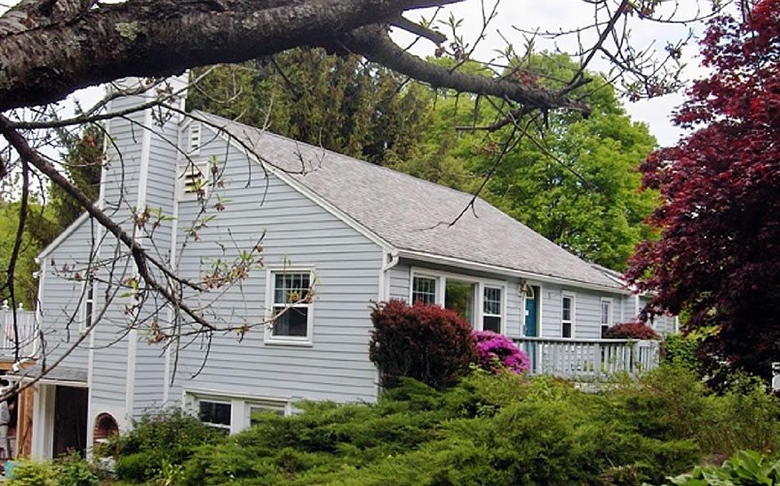
Price Now $225,000 SOLD

Style: Ranch Bedrooms: 3 Bathrooms: 2

Stories: 1 Living Room: 16’ x 15’

Square Feet: 1172 Kitchen: 15’ x 13’

Lot Size: .41 acres Breakfast Nook: 9’ x 5’
Year Built: 1954 Bedroom: 12’ x 10’
Taxes: $3130 Bedroom: 12’ x 10’
Exterior: Wood Mud Room: 15’ x 8’
Roof: Asphalt Shingle Family Room: 15’ x 11’
Electric: 200 Amps, circuit breakers Den: 12’ x 10’
Heat: BBHW CCND MLS: #63182
Mid-Hudson MLS: #243118

Three convenient miles to Metro North. This home offers quiet country living but also the conveniences of many modern upgrades. Black Galaxy Island in kitchen, wonderful wood floors, finished lower level with full bath and fireplace. The walk up attic provides room to expand. Beautifully landscaped yard. Detached studio/workshop. The list goes on and on.

The real estate data for sale on this website is subject to errors, omissions, changes, and withdrawal without notice. Information deemed to be reliable but not guaranteed.

