
3298 Route 343 (East Main Street) PO Box 15 Amenia, New York 12501-0015
TEL: 845.373.8555 FAX: 845.373.9850 eMail: havensre@verizon.net
www.havensre.com

Licensed Real Estate Broker

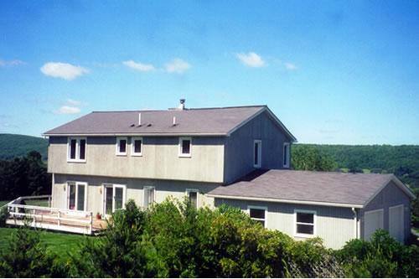 | On Top of the World  30 Quarry Hill Road  Millerton, New York  Spectacular views of the incredible countryside. The sunsets are magnificent. This 1988 Contemporary offers spacious sun-filled rooms. There is work to be done, but the effort will be well worth it. Extremely convenient to state parks, antiquing, a movie theatre, the Harlem Valley Rail Trail and only 18 miles from the Metro North train station.  Price: $350,000 (SOLD)  Taxes: $6496 (2004)  School: Taconic Hills
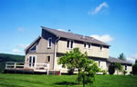

Style: | Contemporary | Bedrooms: | 4
Stories: | 2 | Baths: | 3
Square Feet: | 1,968 | Living Room: | 18’ x 12’9”
Lot Size: | 3.6 acres | Kitchen: | 11’9” x 11’4”
Year Built: | 1988 | Master Bedroom: | 16’6” x 14’9”
Floors: |  | Bedroom #1: | 16’4” x 12’6”
Exterior: | T-111 | Bedroom #2: | 13’ x 12’6”
Roof: | Asphalt Shingle | Bedroom #3/Office: | 11’ x 9’
Heat: | Electric | CCND MLS: | #57601
 |  | Mid-Hudson MLS: | #225041

Additional:
Fireplaces: 1 in Living Room

The real estate data for sale on this website is subject to errors, omissions, changes, and withdrawal without notice. Information deemed to be reliable but not guaranteed.

