Rustic Charm in Millbrook

Licensed Real Estate Broker
308 Hammond Hill Road, Town of Washington

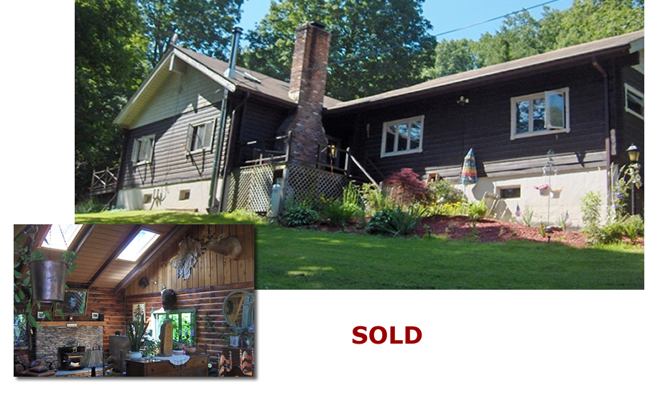

Style: Log Home Bedrooms: 3 Bathrooms: 2

Stories: 1 Living Room: 22’ x 15’

Square Feet: 2,144 Kitchen: 23’ x 14’

Lot Size: 3.43 acres Dining Room: 16’ x 16’
Year Built: 1973 Master Bedroom: 17’ x 13’
Taxes: $6,450 (09) Master Bath: 13’ x 6’ , Sauna
Exterior: Log Bedroom: 15’ x 14’
Roof: Asphalt Shingle Bedroom: 15’ x 14’
Electric: 200 Amps, circuit breakers Loft: 16’ x 12’
Heat: BBHW oil, wood burning boiler Deck: 24’ x 14’
CCND MLS: #74329 Mid-Hudson MLS: #278737

Most Log homes are dark. With more than enough sky lights this home is teeming with natural light and the open floor plan offers an enthusiasm often found in a contemporary home. The 20’ ceiling in the great room is accented by the exposed beams and they are complimented by extraordinary wide board floors and a very distinguished looking stone fireplace. The bathrooms have been tastefully redone and there is a sauna in the master bath. With 3 plus acres this offering is very convenient to the train and the Village of Millbrook. Exceptional charm, stunning space, fabulous location, and a home that looks and feels solid and secure and priced for the conditions of today.
The real estate data for sale on this website is subject to errors, omissions, changes, and withdrawal without notice. Information deemed to be reliable but not guaranteed.
3300 Route 343 (East Main Street) PO Box 15 Amenia, New York 12501-0015
TEL: 845.373.8555 FAX: 845.373.9850 email: havensre@optonline.net.net
www.havensre.com

