Quiet Homestead on Silver Mountain
269 Perotti Road, Town of North East

Licensed Real Estate Broker
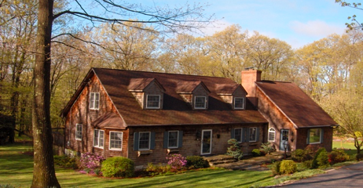
$675,000 REDUCED to $599,000 (Under contract)

Style: Cape Bedrooms: 3 Bathrooms: 2

Stories: 2 Living Room: 21’ x 13’

Square Feet: 2,576 Kitchen: 20’ x 13’

Lot Size: 5.06 acres Dining Room: 14’ x 13’
Year Built: 1987, ’96 addition Family Room: 27’ x 16’
Taxes: $6,609 (09) Bedroom: 13’ x 12’
Exterior: Cedar Shake Master Bedroom: 23’ x 12’
Roof: Asphalt Shingle Bedroom: 14’ x 12’
Electric: 200 Amps, circuit breakers Studio/office/den: 22’ x 14’
Heat: BBHW oil Deck: 34’ x 20’
Fireplace: 2 CCND MLS: #73621
Mid-Hudson MLS: #276837

Tranquility quickly sets in when you enter this property. Set off a hardly-traveled road in a wooded clearing near the top of the highest point in Dutchess County, this low-maintenance cedar shingled cape with 3 car detached garage is reminiscent of country living when life was at its simplest – yet its quality and amenities allow for a carefree lifestyle. Inside features an open floor plan, chamfered solid oak beams downstairs, wide pine floors throughout, butcher block counters, garland range, dining room fireplace,17x23 great room with soaring fieldstone Rumford hearth, and a 5-zone h/w heating system for maximum control and efficiency. On 5 acres with extensive woodland trails and annual/perennial plantings. Only 15 min. to metro-north, 10 min to Village of Millerton.
The real estate data for sale on this website is subject to errors, omissions, changes, and withdrawal without notice. Information deemed to be reliable but not guaranteed.
3298 Route 343 (East Main Street) PO Box 15 Amenia, New York 12501-0015
TEL: 845.373.8555 FAX: 845.373.9850 email: havensre@opyonline.net.net
www.havensre.com

