
Licensed Real Estate Broker

Dream Big
23 Church Street, Millerton, NY
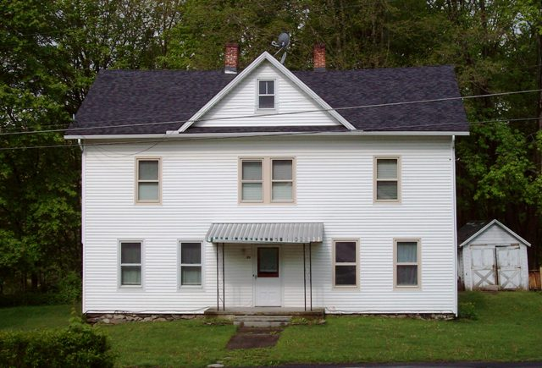
Reduced: $165,000 (SOLD)

Style: Colonial Bedrooms: 3 Bathrooms: 2.5

Stories: 2 Living Room: 29’ x 15’

Square Feet: 2,542 plus a walk up attic Kitchen: 15’ x 10’

Lot Size: .42 acres Dining Room: 15’ x 9’
Year Built: 1910 Double Parlor 15’ x 9’, 15'x9'
Taxes: $3,740 Bedroom: 12’ x 9’
Exterior: Vinyl Bedroom: 15’ x 9’
Roof: AS Bedroom: 15’ x 9’
Electric: 100 Amps, Bedroom: 13' x 9'
Heat: Hot Water Oil
CCND MLS: #76357 Mid-Hudson MLS: #311640

The real estate data for sale on this website is subject to errors, omissions, changes, and withdrawal without notice. Information deemed to be reliable but not guaranteed.
3300 Route 343 (East Main Street) PO Box 15 Amenia, New York 12501-0015
TEL: 845.373.8555 FAX: 845.373.9850 email: havensre@optonline.net
www.havensre.com

