
Licensed Real Estate Broker
3300 Route 343 (East Main Street) PO Box 15 Amenia, New York 12501-0015
TEL: 845.373.8555 FAX: 845.373.9850 email: havensre@optonline.net
www.havensre.com
Packed with Strength and Charm!
21 Briarwood Lane, Town of North East 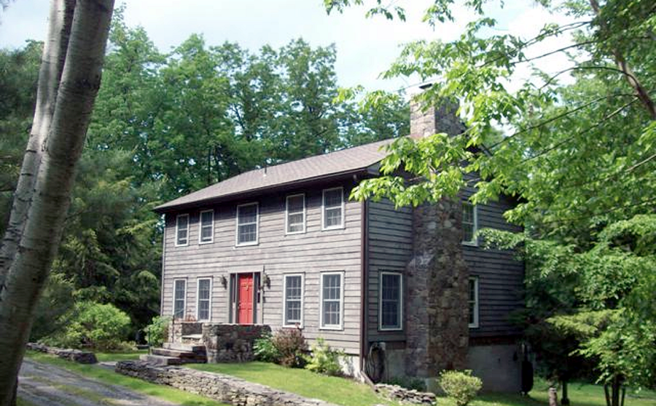
$349,000 (Accepted Offer)

Style: Colonial (Log) Bedrooms: 3 Bathrooms: 2 Full 2 Half

Stories: 2 Living Room: 13’ x 12’

Square Feet: 2,272 Kitchen: 18’ x 13’

Lot Size: 3.1 acres Dining Room: 15’ x 10’
Year Built: 1990 Den: 11 x 9”
Taxes: $6,342 (2013) Master Bedroom: 15’ x 12’
Exterior: Log Bedroom: 12’ x 10’
Roof: Asphalt Shingle Bedroom: 12’ x 10’
Electric: 200 Amps, circuit breakers Full Basement
Heat: BBHW oil Partially Finished Family Room
Mid-Hudson MLS: #315781 CCND MLS: #90245
Unique style log home in a surprisingly private setting. Amenities: wide board floors, exposed beams, 6 panel doors, stone wood burning fireplace and a remarkably private 39' deck. The basement area is set up for teenage fun. This rugged and sturdy home offers style, comfort and spacious country charm and is gracefully balanced by the flowing layout. This is a prime rural area in Eastern Dutchess County. There is a community owned conservation pond and 27 acres of protected land. The Village of Millerton is just minutes away and very convenient to the Harlem Valley Rail Trail, Golf, State Parks and Metro North. There are several private schools that are reasonably close.
The real estate data for sale on this website is subject to errors, omissions, changes, and withdrawal without notice. Information deemed to be reliable but not guaranteed.

