Licensed Real Estate Broker

Fabulous Home, Great Location
206 Depot Hill Rd, Amenia, New York

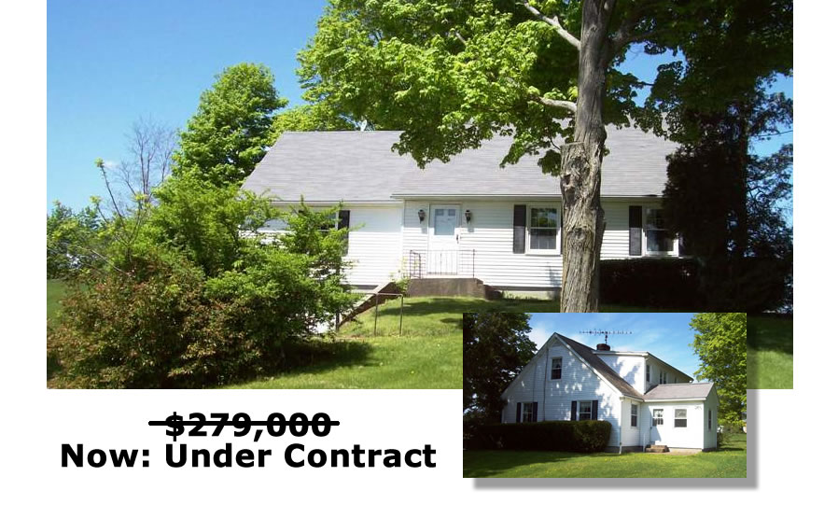

Style: Cape Bedrooms: 4

Stories: 2 Baths: 2

Square Feet: 2,310 Living Room: 22’ x 13’ w/ Fireplace

Lot Size: 1.77 acres Dining Room: 13' x 10’
Year Built: 1958 Kitchen: 13’ x 13'
Taxes: $5,325 (2013) Bedroom: #1: 14’ x 13’
Exterior: Vinyl Bedroom: #2: 13’ x 10'
Roof: Asphalt Shingle Bedroom: #3: 16’ x 11'
Garage: 1.5 car under Bedroom: #4 14' x 13'
Heat: BBHW Oil Fired Den/Office: 11' x 9'

This impressive, well built, 4 bedroom, 2 bath home offers handsome hard wood floors, generous sun filled space and a living room that features a warming fireplace. An outstanding location and an exceptional setting contribute to make this charming 2 level residence a home. Back yards like this are made for children and/or pets. Metro North, the Harlem Valley Rail Trail, Farm Stands, Farm Markets, Summer Theater and State Parks are all very convenient.
The real estate data for sale on this website is subject to errors, omissions, changes, and withdrawal without notice. Information deemed to be reliable but not guaranteed.
3298 Route 343 (East Main Street) PO Box 15 Amenia, New York 12501-0015
TEL: 845.373.8555 FAX: 845.373.9850 email: havensre@optonline.net
www.havensre.com

