
Licensed Real Estate Broker

So private, So close
205 Gun Club Road, Town of North East, New York
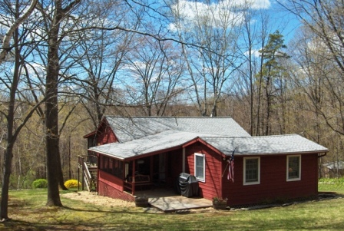
$279,000 UNDER CONTRACT

Style: Cottage Bedrooms: 3

Stories: 1 Bathrooms: 2

Square Feet: 1190 Living Room: 16’ x 13’

Lot Size: 6 acres Kitchen: 14’ x 8’
Year Built: 1942, updated in ‘91 Dining Room: 15’ x 9’
Taxes: $3,422 (2009) Master Bedroom: 16’ x 13’
Exterior: Clapboard Bedroom: 12’ x 10’
Roof: Asphalt Shingle Bedroom: 12’ x 10’
Heat: Electric

Not just a cottage. This partially furnished 3 bedroom, 2 bath home is ready to move into and is located in Millerton, NY. With local farm stands, farmers markets, fine restaurants and coffee shops, a movie theater, State Parks, Harlem Valley Rail Trail, and a variety of golf courses all with in minutes of this private yet convenient location. 6 acres offers room to roam and expand if necessary. NYC is just a train ride away and the Wassaic Station is easily accessible.

The real estate data for sale on this website is subject to errors, omissions, changes, and withdrawal without notice. Information deemed to be reliable but not guaranteed.
3298 Route 343 (East Main Street) PO Box 15 Amenia, New York 12501-0015
TEL: 845.373.8555 FAX: 845.373.9850 email: havensre@optonline.net
www.havensre.com

