
3298 Route 343 (East Main Street) PO Box 15 Amenia, New York 12501-0015
TEL: 845.373.8555 FAX: 845.373.9850 eMail: havensre@verizon.net
www.havensre.com

Licensed Real Estate Broker

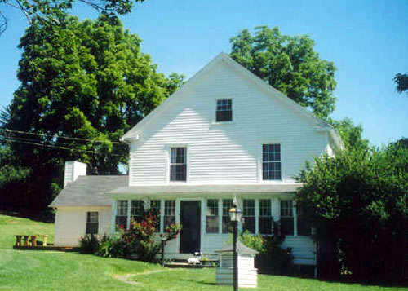 | Charming Country Farmhouse  190 Depot Hill Road  Amenia, New York  Thoughtfully and sensitively renovated 1790’s Colonial Farmhouse enhanced by genuine exposed beams and mellow floors that are rich in character, the family room addition and fireplace have created opportunities that were missing from this cherished antique. Well-proportioned rooms offer family comfort and plenty of room for entertaining. This impeccable home is ready for immediate occupancy. Everything has been updated or replaced including 200 amp electrical service, new boiler, new oil tank, new well and septic, new appliances and fixtures, detached two-car garage.  Price: SOLD  Taxes: $4,261 (2004)  School: Webutuck
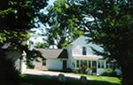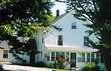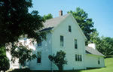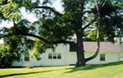

Style: | Colonial Farmhouse | Bedrooms: | 3
Stories: | 2 | Bathrooms: | 3
Square Feet: | 2,150 | Living Room: | 27 x 13
Lot Size: | 1.03 acres | Dining Room: | 13 x 13
Year Built: | 1790 | Kitchen: | 19 x 13
Floors: | Wood | Family Room: | 15 x 14
Basement: | Full unfinished | Enclosed Porch: | 25 x 7
Garage: | 2 car Detached | Master Bedroom: | 14 x 13, 11 x 8
Heat: | Oil, Hot Water, Zoned, Radiators | Bedroom #1 | 13 x 13
 |  | Bedroom #2 | 13 x 13
Additional:
Just minutes from Metro North, Rail Trail State Parks and Golf. The list goes on and on.

The real estate data for sale on this website is subject to errors, omissions, changes, and withdrawal without notice. Information deemed to be reliable but not guaranteed.

