
Licensed Real Estate Broker
3300 Route 343 (East Main Street) PO Box 15 Amenia, New York 12501-0015
TEL: 845.373.8555 FAX: 845.373.9850 email: havensre@optonline.net
www.havensre.com

Village Proud
18 Highland Drive, Village of Millerton, New York
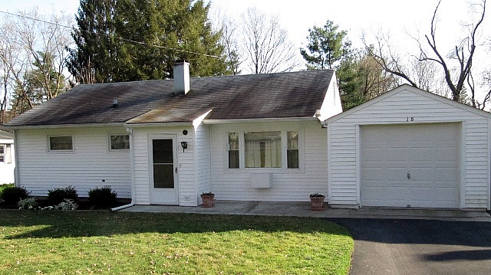
$162,000 Now: $147,500 (SOLD)

Style: Ranch Bedrooms: 3

Stories: 1 Bathrooms: 1

Square Feet: 875 Living Room: 16’ x 12’

Lot Size: .3 acres Kitchen: 12’ x 10’
Year Built: 1955 Bedroom: 12’ x 9’
Taxes: $2,035 (2012) Bedroom: 12’ x 7’
Exterior: Vinyl Bedroom: 12’ x 8’
Roof: Asphalt Shingle CCND MLS: #83909
Heat: Hot Air Oil Mid-Hudson MLS: #305444

Located on a quiet and comfortable tree lined street just minutes from the Village Center.
The yard is level and plenty large enough for pets and or gardens. There are no stairs to the house or garage. This bright and cheery home is in impeccable condition offering pride of ownership and easy maintenance. An adorable 3 bedroom home featuring an enclosed porch creating additional living space for a large part of the year and the home is wired for a generator. State Parks, New England Villages, Golf, Biking and Hiking are so close. Metro North is just 12 miles away.

The real estate data for sale on this website is subject to errors, omissions, changes, and withdrawal without notice. Information deemed to be reliable but not guaranteed.

