
3298 Route 343 (East Main Street) PO Box 15 Amenia, New York 12501-0015
TEL: 845.373.8555 FAX: 845.373.9850 eMail: havensre@verizon.net
www.havensre.com

Licensed Real Estate Broker

Mountain View
16 Mountain View Road
Amenia, New York

Don’t miss this opportunity to own an exceptional home & property. Great location, quiet street, beautiful, mature plantings, invigorating in-ground pool, sunny deck, 2 acres of open rolling lawn framed by evergreens for privacy and year round color. Impressive floor plan radiating hospitality and country living. Generously sized rooms including a large Master Bedroom and Master Bath. There is a full, dry, unfinished basement and an attached two-car garage.

Price: SOLD

Taxes: $4,822 (2004)

Town tax: $

School: Webutuck
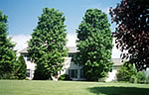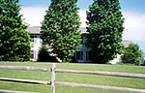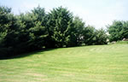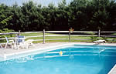

Style: | Colonial | Bedrooms: | 3
Stories: | 2 | Bathrooms: | 2.5
Square Feet: | 2,592 | Living Room: | 18 x 13
Lot Size: | 2.11 acres | Dining Room: | 13 x 13
Year Built: | 1993 | Kitchen: | 12 x 11
Floors: |  | Family Room: | 20 x 13
Basement: |  | Dining Room: | 13 x 10
Garage: | 2 car attached | Master Bedroom: | 17 x 17
Heat: | BBHW Oil | Bedroom #1: | 16 x 13
 |  | Bedroom #2: | 13 x 10

Additional:
Just minutes from Metro North, Rail Trail State Parks and Golf.

