
Licensed Real Estate Broker

So affordable, So convenient
169 Beilke Road, Town of North East, New York
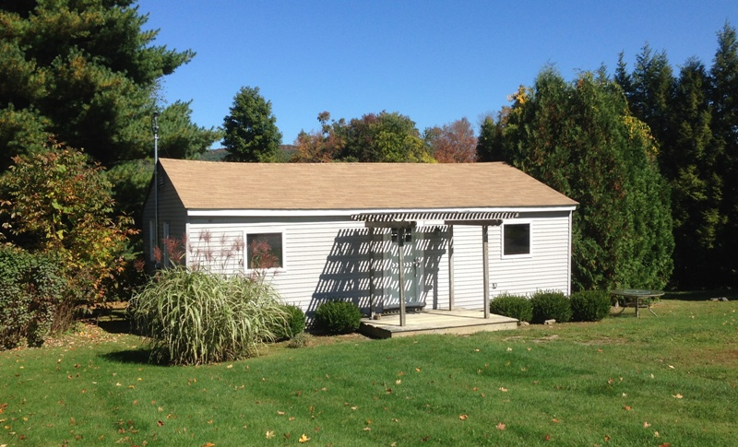
SOLD

Style: Cottage Bedrooms: 2

Stories: 1 Bathrooms: 1

Square Feet: 1000 Living Rm/Great Rm:19’ x 17’

Lot Size: .55 acres Kitchen: 13’ x 9’
Year Built: 1940 , updated in ‘02 Bedroom: 19’ x 9’
Taxes: $2,754 (2014) Bedroom: 10’ x 10’
Exterior: Vinyl Bathroom: 9' x 8'
Roof: Asphalt Shingle CCNDMLS: #99662
Heat: BBHWO Mid Hudson MLS # 333160

Not just a cottage. The vistas are truly amazing! This fully equipped 2 bedroom, 1 bath home is ready to move into and is located in Millerton, NY. Local farm stands, farmers markets, fine restaurants and coffee shops, a movie theater, State Parks, Harlem Valley Rail Trail, and a variety of golf courses all with in minutes of this accessible convenient location. .55 acres offers room to roam and expand if necessary. NYC is just a train ride away and the Wassaic Station is easily 15 miles away.

3300 Route 343 (East Main Street) PO Box 15 Amenia, New York 12501-0015
TEL: 845.373.8555 FAX: 845.373.9850 email: havensre@optonline.net
www.havensre.com

The real estate data for sale on this website is subject to errors, omissions, changes, and withdrawal without notice. Information deemed to be reliable but not guaranteed.

