
3298 Route 343 (East Main Street) PO Box 15 Amenia, New York 12501-0015
TEL: 845.373.8555 FAX: 845.373.9850 eMail: havensre@verizon.net
www.havensre.com

Licensed Real Estate Broker

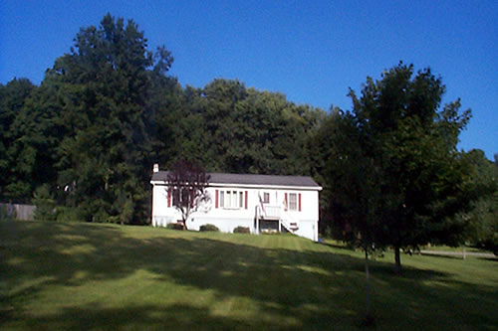 | A Picturesque Setting  15 Stone Avenue  Millerton, New York  A picturesque setting for this cheerful 3 bedroom, 2-bathroom home just outside the Village of Millerton. Make yourself at home in this quietly located single floor home with spacious rooms and vaulted ceilings. The large yard is perfect for gardening and children have ample room to play. There is a very private deck and a basement just waiting to be finished.  Price: SOLD
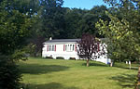

Style: | Ranch | Bedrooms: | 3
Stories: | 1 | Bathrooms: | 2
Square Feet: | 1,352 | Living Room: | 18x12
Lot Size: | .940 acres | Kitchen: | 19x12
Year Built: | 1992 | Master Bedroom: | 14x12
Floors: |  | Bedroom 1: | 14x12
Exterior: | Vinyl | Bedroom 2: | 12x11
Roof: | Asphalt Shingle | CCND MLS: | #222651
Heat: | BBHW, Oil | Mid-Hudson MLS: | #56788

Additional: State Parks, the Rail Trail and the Town Recreation Park are all just minutes away. Metro North is only 13 miles away. Waiting room at ground level.

The real estate data for sale on this website is subject to errors, omissions, changes, and withdrawal without notice. Information deemed to be reliable but not guaranteed.

