
Licensed Real Estate Broker

A Dream Setting
156 Mountain Rd. Town of Stanford, NY
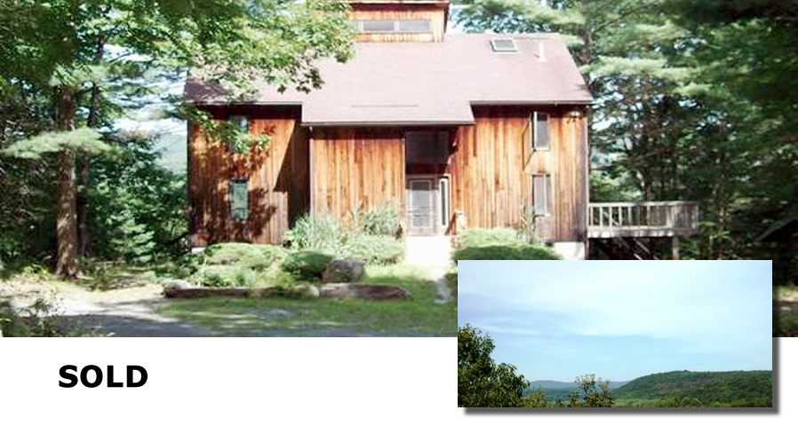

Style: Contemporary Bedrooms: 3 Bathrooms: 2

Stories: 2 Living Room: 25’ x 23’ w/woodstove

Square Feet: 2,028 Kitchen: 13’ x 10’

Lot Size: 3.74 acres Dining Area: 13’ x 8’
Year Built: 1986 Bedroom: 25’ x 11’ w/ loft
Taxes: $8,118 Bedroom: 12’ x 12’ w/loft
Exterior: Vertical Cedar Master Bedroom: 17’ x 12’
Roof: Asphalt Shingle Basement: Full and useable
Electric: 200 Amps, circuit breakers CCND MLS: #86076
Heat: Electric Mid-Hudson MLS: #309035

Located about halfway between Pine Plains and Stanfordville, this whimsical setting abuts hundreds of protected acres owned by the Audubon Society. The vistas across and up and down the valley are breathtaking. This invigorating environment challenges future owners to create something unique and rewarding on this very special setting by pulling this house together (it needs work) or starting over. Mashomack Preserve is just up the road. Millbrook and Rhinebeck are short drives away and there is relatively easy access to the Taconic State Parkway. Location! Privacy! Location! Privacy!

The real estate data for sale on this website is subject to errors, omissions, changes, and withdrawal without notice. Information deemed to be reliable but not guaranteed.
3300 Route 343 (East Main Street) PO Box 15 Amenia, New York 12501-0015
TEL: 845.373.8555 FAX: 845.373.9850 eMail: havensre@optonline.net
www.havensre.com

