
Licensed Real Estate Broker
3300 Route 343 (East Main Street) PO Box 15 Amenia, New York 12501-0015
TEL: 845.373.8555 FAX: 845.373.9850 eMail: havensre@verizon.net
www.havensre.com

Boulevard District
143 Route 44, Town of North East, New York
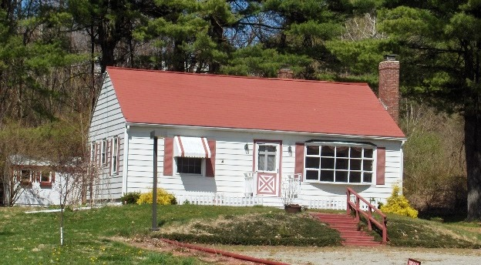
$248,500 "SOLD"

Style: One Level Bedrooms: 2

Zoning: Boulevard District #2 Bathrooms: 1

Square Feet: 952 Living Room: 20’ x 13’ w/Fireplace

Lot Size: .61 acre Kitchen: 11’ x 9’
Year Built: 1953 Dining Room: 11’ x 10’
Taxes: $2,824 (2006) Bedroom: 13’ x 10’
Exterior: Vinyl Bedroom: 12’ x 10’
Roof: Asphalt Shingle CCND MLS: #62906
Heat: Forced Hot Air oil Mid-Hudson MLS: #242200

This very neat package is ideal for a small office or a grander plan because of the location and setting in the Boulevard District #2. Now vacant this single family home with glistening hardwood floors can be converted to business use with little or no effort. The traffic is high and the activity is never ending at this location and there is plenty of parking. The Village of Millerton is within walking distance. Metro North, State Parks, Golf and the Harlem Valley Rail Trail, fine restaurants and the Movie House are all within minutes of this building. This is a Golden Opportunity.
Directions: From the light at the intersection of Routes 22 & 44 in Millerton – East on Route 44 to #143 on the Left.

The real estate data for sale on this website is subject to errors, omissions, changes, and withdrawal without notice. Information deemed to be reliable but not guaranteed.

