143 Carson Rd, Town of Ancram, New York

Licensed Real Estate Broker
3298 Route 343 (East Main Street) PO Box 15 Amenia, New York 12501-0015
TEL: 845.373.8555 FAX: 845.373.9850 eMail: havensre@verizon.net
www.havensre.com

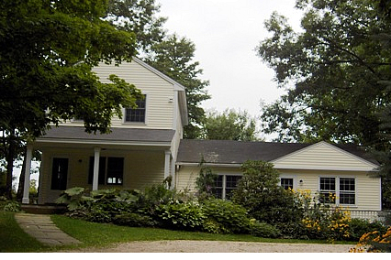
$575,000 (SOLD)

Style: Traditional Bedrooms: 2

Stories: 2 Baths: 2 full

Square Feet: 1657 Living Room: 25’ x 14’

Lot Size: 2.66 acres Dining Room: 10’ x 9’
Year Built: 1950 Kitchen: 13’ x 10’
Taxes: $3882 (2005) Heated Sun room: 11’ x 10’
Exterior: Clapboard Master Bedroom: 18’ x 10’
Garage: Detached (W/workshop) Bedroom: #2: 13’ 6’ x 10’
Heat: Base Board, Gas, Hot water Den/Office: 15’ x 12’

With unbelievable privacy this amazing horticultural paradise is in an irresistible location and setting. This home is filled with subtle character and tranquil charm. The views of distant fields and your own vibrant gardens are energizing. A wonderful feel of home that should not be overlooked.

The real estate data for sale on this website is subject to errors, omissions, changes, and withdrawal without notice. Information deemed to be reliable but not guaranteed.

